Analysis of Dynamic Response Characteristics of Transmission Conductors under Ice Shedding Impact of Ground Wires
Jian Wang, Leijie Liu, Xianfeng Li, Nan Chen, Dongliang Luo, Rakhmonov Ikromjon Usmonovich
Abstract--Besides natural shedding, ground wire ice-shedding impacts more readily trigger large-scale conductor ice shedding. This paper innovatively proposes a numerical simulation method for conductor dynamic responses to ground wire ice-shedding impacts in transmission lines. Using finite element models, it studies the ice-shedding dynamics of four-bundle conductors under various impact scenarios and structural parameters, verified by a 1:20 reduced-scale model. The research indicates that under the median impact condition, the ice shedding impact of the ground wire has the greatest influence on the ice shedding of the entire conductor span. As the ice shedding impact rate increases, the growth rate of the jumping height during the ice shedding of the entire span of the conductor shows an upward trend, while the growth rate of the jumping height during the local ice shedding of the conductor remains approximately constant. Under the lateral impact condition, the maximum conductor jumping height occurs near the impact point. Finally, a formula for calculating conductor jumping height after ground wire ice-shedding impacts is proposed, which is crucial for icing-area transmission line design.

Index Terms--Ice shedding impact of ground wires, Jumping height, dynamic response of conductors, numerical simulation, transmission line,reduced-scale test.

Introduction
I
CE SHEDDING and jumping of transmission lines will cause the conductors to jump up and down and swing horizontally. When the safety clearances between conductors and between conductors and ground wires are insufficient, it is extremely likely to trigger electrical accidents such as flashover and conductor burning [1],[2].In reality, the design of transmission towers takes into account the horizontal deviation of conductors and ground wires, which ensures that conductors and ground wires maintain a spatial offset under normal working conditions. However, under the influence of strong wind disturbances or the swaying and dancing of ice-covered conductors, conductors and ground wires will swing in a complex manner, and they will likely be located on the same vertical line, forming a vertical collinear configuration of conductors and ground wires. The ground-wire ice-shedding impacts refer to the local impact generated when the ice shedding from ground wires often strikes the conductors when the conductors and ground wires are partially in the same vertical direction. There have been extensive studies on the dynamic characteristics of ice shedding and jumping of transmission lines.[3]-[5] However, investigations into a large number of icing accidents of transmission lines have shown that the probability of ice shedding and jumping caused by the coupling between conductors and ground wires due to the ground-wire ice-shedding impacts is quite high. The result may lead to an increase in the jumping height of the conductors and the impact force they bear. Therefore, it is of particular importance to study the dynamic response of transmission lines when the ground-wire ice-shedding impact occurs.
In existing studies, scholars have conducted extensive research on transmission line ice shedding and jumping heights using methods such as scaled tests, numerical simulations, and simplified models. Morgan and Swift [6] first conducted experimental research on five-span transmission line ice-shedding jumps in 1982 by releasing heavy objects to simulate mid-span ice load shedding. Jamaleddine et al. [7] established a two-span scaled transmission line model in an artificial climate laboratory, using numerical simulations to analyze ice-shedding-induced changes in jumping height and tension. Van Dyke et al. [8] performed three mid-span ice block shedding tests to investigate chain-like ice shedding effects. However, all these tests used small-scale models, and due to factors such as the scale effect of the models and differences in boundary conditions, the results may not accurately reflect the actual situation.
Jamaleddine [7] and others first established a reduced-scale two-span nonlinear finite element model. By releasing the concentrated loads distributed on the conductors to simulate the ice shedding process, they studied the dynamic response of the transmission line during ice shedding. On this basis, researchers have carried out extensive numerical simulation studies [9]-[12]. Kalman [13] and Mirshafiei [14], and others, respectively, analyzed the dynamic responses of ground wires and conductors affected by the impact-induced ice shedding by numerical methods. Wang [15] and others studied that partial ice shedding may result in a higher jumping height than full-span ice shedding, and the maximum jumping point does not necessarily appear at the mid-span. JI [16] and others proposed a new conductor ice shedding model, which considered the adhesive forces between the conductors and the ice as well as within the ice, and conducted an analysis of the dynamic characteristics of the conductor ice shedding and jumping, and also studied the ice shedding effect under induction [17]-[19]. However, these studies have all focused on the changes in the jumping height and tension of the conductors of the transmission line after natural ice shedding, without considering the influencing factors of the ground-wire ice-shedding impacts, and only conducting numerical modeling for the conductors.
In addition, scholars have conducted theoretical studies on the ice shedding and jumping height of transmission lines. Oertli [20] proposed an integral formula for calculating the ice jumping height of conductors after ice shedding, concluding that the jumping height depends on the mass per unit length of the conductors and the ice load. Lips [21] derived a calculation formula that can determine the jumping height of conductors after ice shedding, and the study found that the jumping height is related to the tension of the conductors under the action of ice load and without ice load. Morgan and Swift [6] provided a calculation method for the ice shedding and jumping height that can ignore the vertical displacement of the suspension points during the vibration of the conductors after ice shedding and the change in the tension on the conductors. The approximate formula proposed by List and Pochop [22] indicates that the jumping height depends on the tension, elastic modulus, and density of the conductors when they are ice-covered. In the design code of transmission lines in China [23], the estimation formula for the jumping height proposed by the former Soviet Union is adopted. However, all of these are based on simplified theories, experiences, or experiments, and cannot be applied to the more complex ice shedding impact effects of ground wires in reality, nor can they calculate the jumping height under different structural parameters and different impact effects.
In this paper, based on the kinetic energy equation of ice shedding impact, a numerical simulation method for the double-layer ice shedding impact of conductors and ground wires in transmission lines is proposed to realize the coupled dynamic response of conductors and ground wires after the ground-wire ice-shedding impacts. For the first time, a 1:20 reduced-scale test platform for the ice shedding impact of the double-layer conductors and ground wires is built to simulate the impact of the conductors after the ice shedding of ground wires. The dynamic response of four-bundle conductors under full-scale size, subjected to different impact working conditions (impact positions and numbers of impacts) and different line parameters, is studied. Based on the data of the jumping height of the conductors, a calculation formula for the jumping height of the conductors after being impacted by the ice shedding of ground wires is proposed, providing a reference for the rapid prediction of the jumping height of the conductors after the ice shedding impact. The research results are of great significance for the design of transmission lines in ice-covered areas.

Numerical Simulation Methods For Ice-Cover Impacts

Ice Accretion Impact and Shedding Patterns
When the conductors and ground wires are partially in the same vertical direction, the impact of ground-wire ice shedding often occurs. Fig. 1(a) shows that the impact of ground-wire ice shedding in an actual transmission line causes large-scale ice shedding of the conductors. When the ice-covered conductor is impacted, a complex ice shedding mode occurs. To simplify the research, this paper simulates the impact of ground-wire ice shedding by releasing heavy objects with electromagnets. As shown in Fig. 1(b), the left side shows the falling process of the heavy objects before the impact, and the right side shows the moment when the heavy objects impact the electromagnet, thereby simulating the impact of ground-wire ice shedding.
In order to study the effect of the ground-wire ice-shedding impact on the conductor ice-shedding jump, based on the research of Wang et al [10], this paper studies the influence of the impact at the side-position (lateral impact) of the ground-wire ice shedding and the impact at the middle-position (median impact) on the ice-shedding jump of the single-phase four-bundle conductors. When the total amount of shed ice is the same for ice-covered transmission lines, the maximum jump height of conductors during synchronous ice shedding is usually greater than that during delayed chain-like ice shedding. Therefore, in this paper, the conductor ice shedding triggered by the ground-wire ice-shedding impact is assumed to be synchronous ice shedding without delay.
Here, the ground-wire ice-shedding impact rate (ice-shedding impact rate) is defined as the percentage of the amount of shed ice on the ground wire to its total ice-accretion amount, which is used to characterize the degree of ground-wire ice shedding. The ice-shedding modes are set according to the position of the ground-wire ice-shedding impact, as shown in Fig.2. In Fig.2(a), the conductor is subjected to a lateral impact. The lateral impact ice-shedding impact position of the ice is set as x=0.25, where x is the projection point of the ice-shedding node unit on the x-axis. When Lx is 50% of L, it means that 50% of the ice on the left side of the conductor has shed. In Fig.2(b), the conductor is subjected to a median impact. The median impact ice-shedding position of the ice is x=0.5. When Lx in the middle is 50% of L, it means that 50% of the ice in the middle of the conductor has shed. h0 is the vertical distance between the conductor and the ground wire.
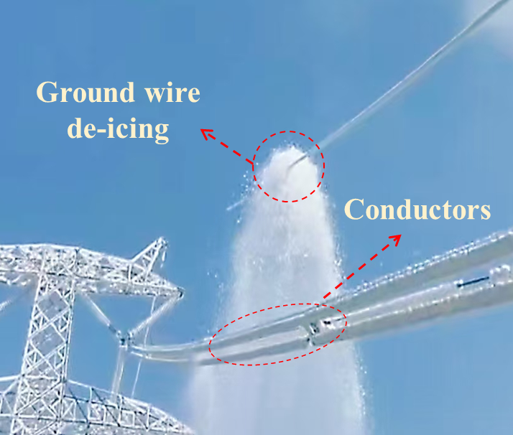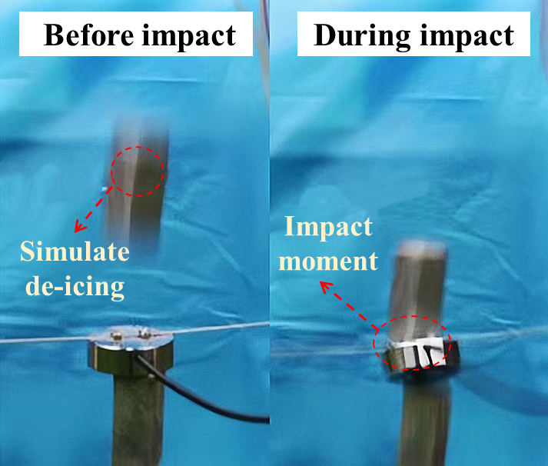
- (b)
Fig. 1. Ice-shedding impact of ground wire. (a) Impact in on-site scenarios; (b) Impact in experimental simulations.

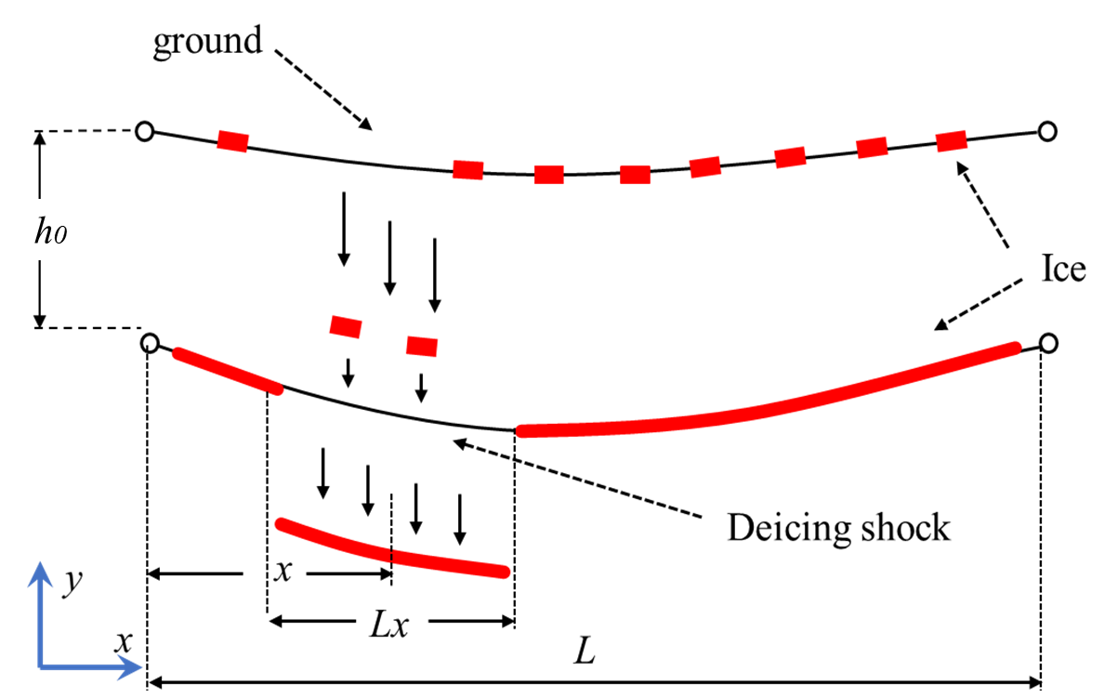
(a)
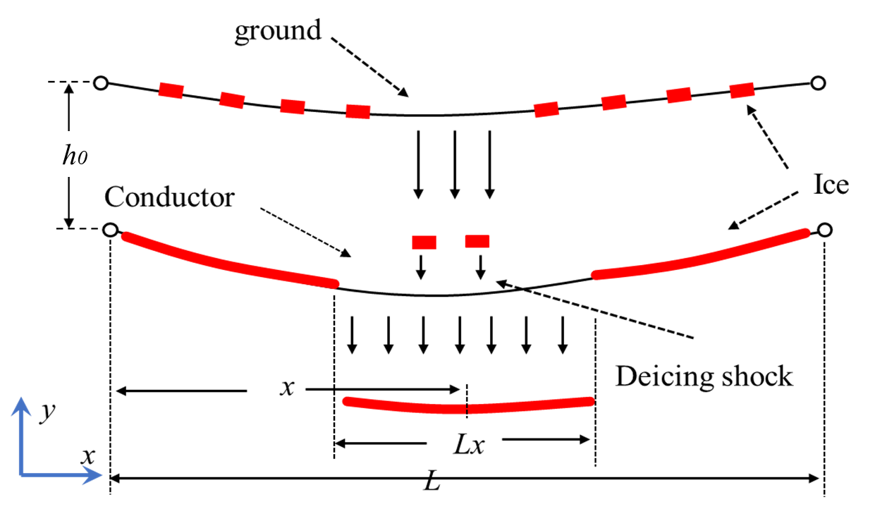
(b)
Fig. 2. Definition of the ice shedding impact pattern of ground wires. (a) The ice shedding of conductors under lateral impact; (b) The ice shedding of conductors under median impact.

Format Finite Element Simulation and Line Parameters
In order to simulate the impact effect of ground-wire ice shedding, this paper assumes that the conductors and ground wires of the transmission line are in the same vertical direction. Using the finite element simulation software ANSYS, a single-span double-layer model of conductors and ground wires is established, which includes the upper-layer ground wire, the lower-layer bundled conductors, and the spacers. According to the parameters of the actual spacer dampers, the Young's modulus and Poisson's ratio are 210 GPa and 0.3, respectively. Since the change in the maximum jump height of the conductors after ice shedding is minimally affected by the deformation of the towers, the influence of the transmission tower poles can be ignored [24].
TABLE I
Parameters pertaining to the conductor and the ground wire
Conductor type | S(mm²) | D(mm) | W(kg/m) | E(GPa) | v
LGJ-300/50 | 348.36 | 24.26 | 1.133 | 70 | 0.3
LGJ-400/25 | 424.28 | 26.82 | 1.296 | 74 | 0.3
LGJ-400/50 | 451.555 | 27.63 | 1.511 | 69 | 0.3
JLB-150 | 194.83 | 15.75 | 0.696 | 105 | 0.3

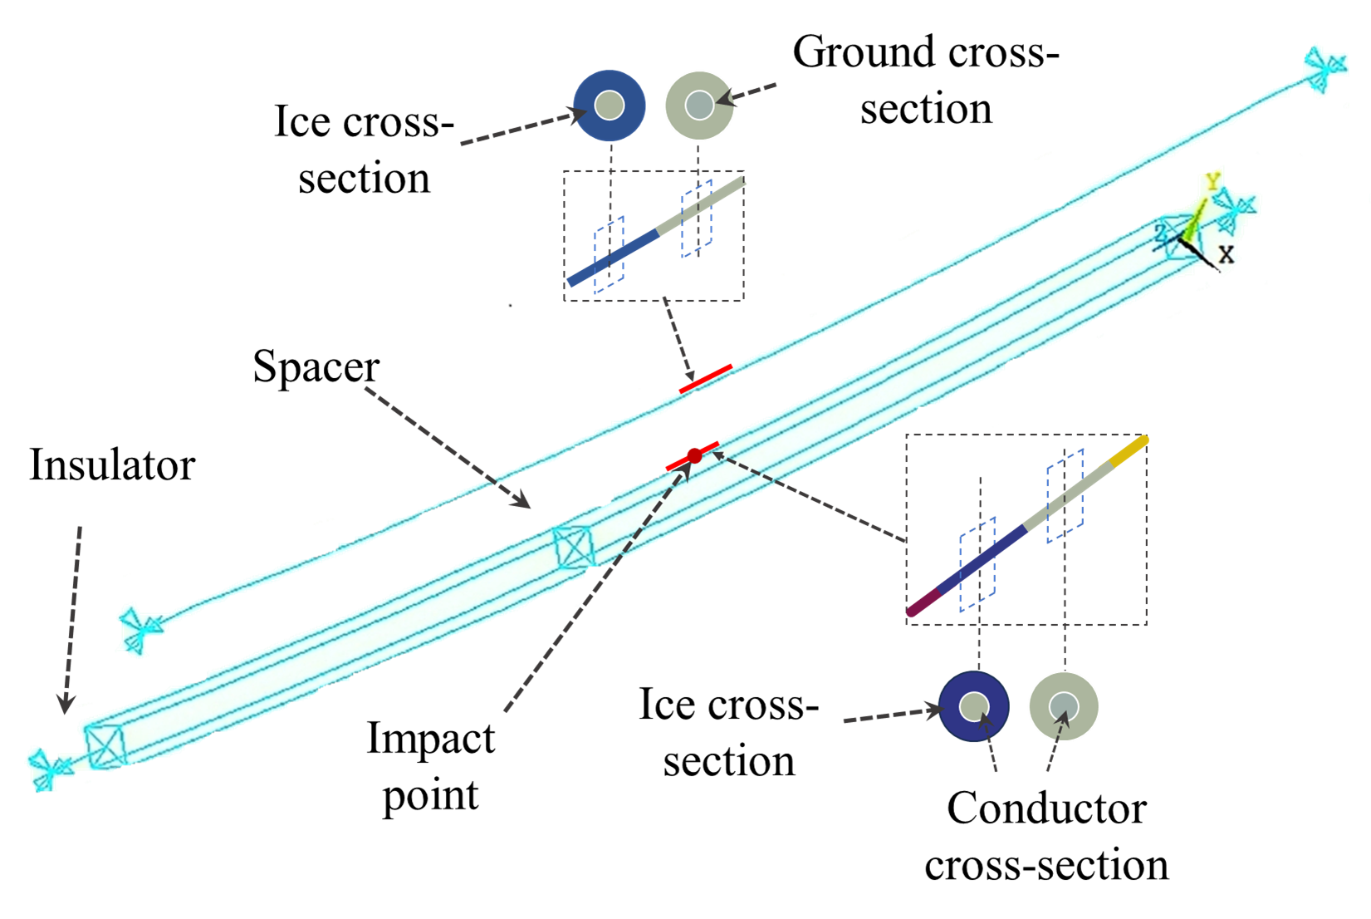
Fig. 3. FE modeling of ice-covered four-bundle conductors and ground wires.

The single-phase conductors and ground wires are simulated by using the rod element LINK10. LINK10 is a linear element with prestress, which can simulate the aluminum-conductor steel-reinforced (ACSR) wire that can only bear tensile force but not compressive force. The two ends are fixedly connected.
In this paper, the iterative method is used for the form-finding analysis to determine the initial deformation of the conductors and ground wires under their weight [25]. Due to the different parameters of the conductors and ground wires, there will be obvious differences in the sags of the two after the iterative form-finding. According to the vertical distance and the initial shape of the conductors and ground wires, 40 nodes are set for each of the upper and lower layers, and an integrated model of the conductors and ground wires is established through these points, respectively. The physical parameters of the conductors and ground wires are shown in Table I. Considering the importance of damping, according to the literature [26], the viscous damping constant of the bare conductor is set to 2% of the critical damping. B. Simulation Settings of the Impact of Ground-wire Ice Shedding.

Simulation Settings for Ground-Wire Ice-Shedding Impact
In the design of ice accretion and ice shedding for overhead transmission lines, it is generally assumed that the ice accretion on the lines is evenly distributed. Both ends of the line are fixed, and a finite element model of the ice-covered double-layer structure four-bundle conductor-ground wire is constructed, as shown in Fig. 3. The ice accretion units are established by using the mass element method, and the ice accretion is simulated by using the MASS21 element. The Young's modulus, Poisson's ratio, and density of the ice are 10 GPa, 0.3, and 900 kg/m³, respectively[27]. Each ice unit shares the same position as the nodes on the conductors and ground wires. The element birth and death method is adopted, and the EKILL command is used to "kill" the ice accretion units under different working conditions, so as to achieve the shedding of the ice accretion.
In order to achieve the impact effect of the ground-wire ice shedding on the conductors, this paper, for the first time, uses the impact kinetic energy equation to simulate the impact on the ice-covered points of the conductors. It is assumed that when the upper-layer ice-covered units shed, they start to fall freely. The air resistance and the energy loss during the impact are considered as shown in formula (1).
(1)
where E_{drag} is the loss caused by air resistance, E_{crush} [28],[29] is the loss due to crushing during ice-shedding impact, E_{p} is the relative potential energy of the ice accretion on the ground wire relative to the conductor, and E_{k} is the kinetic energy of the ice-shedding impact, and the unit of all of them is joule (J).
(2)
“(2)” is the impact momentum formula, which is used to represent the impulse received by each node on the conductor. Where F is the impact force received by the conductor node, t is the impact time, m is the mass of the ice shedding at the ground wire node, and v is the impact velocity. The impulse of the ice-shedding impact of the ground wire on each node of the conductor is calculated. Considering that the impact time is generally 0.01 s, a vertically downward acting force is set to be applied to the nodes of the lower-layer conductor. After the action of the impact time t, the impact effect on the conductor is achieved by removing the impact force. At the same time, the EKILL command is used to control the ice shedding of the lower-layer conductor, triggering a new dynamic response of the conductor. The displacement time history of the maximum ice-shedding jump point of the conductor is recorded in the simulation.

Verification of Numerical Simulation
To verify the accuracy and reliability of the ground-wire ice-shedding impact model in this paper, a 1:20 double-layer conductor-ground wire ice-shedding reduced-scale test platform in an isolated span was built to simulate the impact effect on the conductors after the ground-wire ice shedding.

Construction of reduced-scale Model
Based on the similarity principle of the transmission line reduced-scale model in reference [30], a double-layer conductor-ground wire ice-shedding impact reduced-scale test platform was established to simulate the coupled dynamic response of the conductors and ground wires caused by the impact of the ground wire on the conductors after ice shedding. The span of the prototype line is 400 m, the conductor used is LGJ-400/25 with an initial tension of 50 MPa, and the ground wire used is JLB-150 with an initial tension of 45 MPa.

TABLE II
Physical Parameters of the Test Steel Wire Rope

Diameter of the Steel Wire (mm) | structure | Cross-sectional area(mm²) | Young's modulus(GPa)
1.2 | 7*7 | 1.13 | 108
0.8 | 1*7 | 0.5 | 125

TABLE III
Reduced-Scale Factors Between the Prototype and The Reduced-Scale Model

Physical Quantity | $$C_{l}$$ | $$C_{E}$$ | $$C_{ρ}$$ | $$C_{F}$$
Conductor | 0.05 | 1.46 | 29.2 | 3.65*10⁻³
Ground Wire | 0.05 | 1.19 | 23.8 | 2.98*10⁻³
Note: C_{L}: length ratio, C_{E}: stiffness ratio, C_{ρ}:density ratio, C_{F}: force ratio.

The vertical height h0 between the conductor and the ground wire is 10 m. The specific parameters of the prototype conductor and ground wire are shown in Table I. In the reduced-scale model, a 304-material steel wire rope with a diameter of 1.2 mm is used to simulate the transmission conductor, and a steel wire rope with a diameter of 0.8 mm is used to simulate the ground wire. The parameters of the steel wire ropes are shown in Table II. According to the similarity principle, the similarity ratios between the prototype and the reduced-scale model are shown in Table III. The span length of the reduced-scale test model is 20 m with no elevation difference. Extra mass blocks are attached to the upper and lower steel wire ropes, respectively, to meet the similarity ratio relationship.

Reduced-Scale Test System
The test system consists of a single-span transmission line, a double-layer conductor-ground wire reduced-scale model shown in Fig. 4, a tension sensing device, and a high-speed camera. Since the influence of the tower body on the ice-shedding jump is minimal, two fixed circular steel columns are used to replace the tower. The two ends of the steel wire rope are fixed to the support columns through tension sensors, which are connected to a computer to record the change in tension of the steel wire rope over time before and after ice shedding. The sampling frequency is set to 100 Hz. To simulate uniform conductor icing, 10 equal-mass weights are attached by electromagnets on the upper and lower layers, spaced 2m apart. Based on the similarity principle, through equivalent conversion, the weights for 10mm, 15mm, and 20mm ice thicknesses are determined to be 240g, 420g, and 620g, respectively. Electromagnets controlled by a time relay are evenly suspended on the steel wire rope. When current passes through, heavy objects are tightly adsorbed on the electromagnets to simulate ice accretion on the line. When the current is cut off, the heavy objects are released to simulate the shedding of the ice accretion.
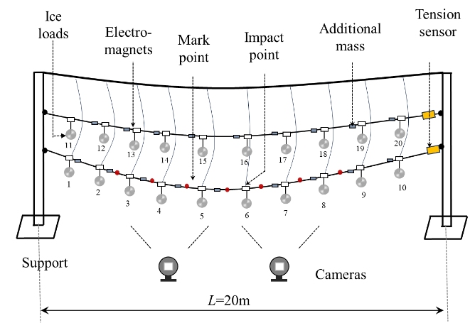
(a)
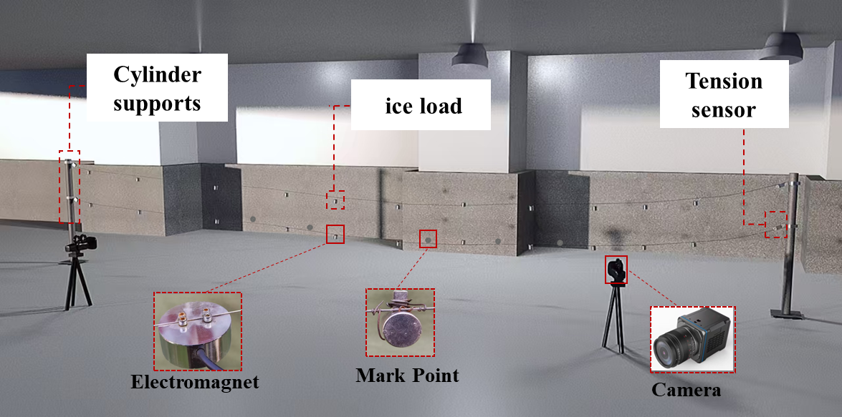
(b)
Fig. 4. Reduced-scale test system. (a) Schematic diagram; (b) Test system.

To achieve the impact effect of ground-wire ice shedding and ensure that the upper and lower electromagnets are in the same vertical direction, the time relay circuit is controlled to turn off, enabling the upper heavy objects to accurately hit the lower electromagnets, thus simulating the impact force generated by the ground-wire ice shedding on the conductors in reality. By selecting the sequence and number of controlled relays, the ice-shedding dynamic responses of the conductors triggered by ice-shedding impacts at different positions and quantities of the ground wire can be simulated. Due to the complex vibration patterns of the conductor before and after it is impacted and experiences ice shedding, accurately measuring the maximum jump height of the steel wire rope after ice shedding of the model is a key aspect of the research. Eight mark points were set on the conductor respectively, and two high-speed cameras were used to collect the jump curves of the steel wire rope after ice shedding.

Test Results
1) Experimental Tests: Due to the high volatility of the reduced-scale impact tests, 40 tests were designed for each group to prevent interference from accidental data. Equivalent weights for 15 mm ice accretion were set, and by controlling the same ice-shedding length L_{x} of the steel wire rope, the experimental results are shown in Fig. 5. Among them, Fig. 5 (a-1) represents the initial state, and Fig. 5(a-2) represents the state at the maximum jump height. It can be seen that the jump height of the simulated steel wire rope is 18.62 cm when it is not impacted by heavy objects. When it is impacted, Fig. 5(b-1) is the initial state, Fig. 5(b-2) is the impact state, and Fig. 5(b-3) is the state at the maximum jump height. As shown in Fig. 5(b-2), an additional sag, $Δf$ = 6.43 cm, is generated first. At
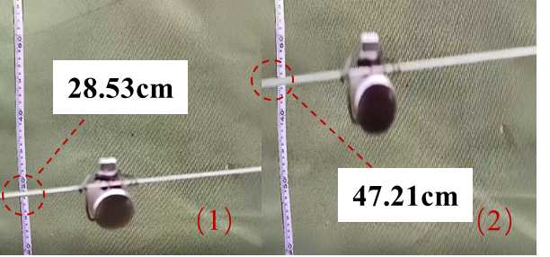
(a)
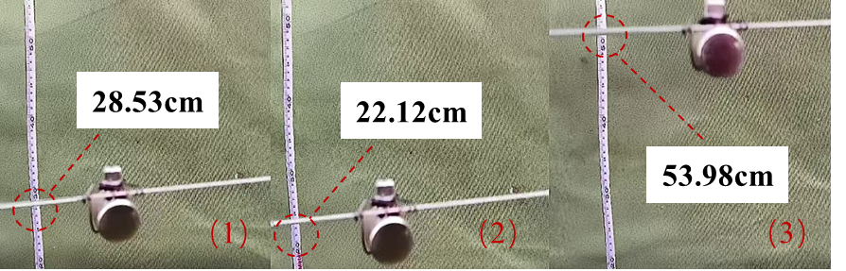
(b)
Fig. 5. Comparison of the jumping heights of the conductors before and after being impacted. (a) Impacted by heavy objects; (b) Not impacted by heavy objects.

this time, the electromagnet is controlled to release the lower-layer heavy object. Under the superposition effect of the upper-layer and lower-layer heavy objects, the lower-layer steel wire rope generates a larger jump, with a height of 25.45 cm. Evidently, under the impact of heavy objects, the ice-shedding jump height of the experimental conductor increases significantly.
2) Verification Results: By establishing a finite element model of the prototype line and setting equivalent weights for 15 mm ice accretion, the dynamic responses of the experimental line after ice shedding under three conditions were numerically simulated. Through scaling with a length ratio of 1/20 for comparison, Fig.6 shows the comparison of the displacement time-history curves of the maximum jump points of the conductor with and without the impact of ground-wire ice shedding, as well as the comparison results of the maximum jump heights between the simulation and the reduced-scale model when the conductor has different ice-shedding lengths L_{x} /L.
Fig. 6(a) shows the dynamic vertical displacements of the experimental and simulated conductors without the impact of heavy objects. It can be seen that the two curves match well within the first cycle, and the error gradually increases over time. This is because the damping ratios of the finite-element model and the actual situation are different, resulting in different vibration peak values. Fig. 6(b) is a comparison diagram of the maximum jump heights of the conductor under different ice-shedding lengths without the impact of heavy objects. It can be seen that the errors are all within 6%. After applying a 40% ground-wire ice-shedding impact rate to the conductor, Fig. 6(c) presents the dynamic vertical displacements of the experimental and simulated conductors when subjected to the impact of heavy objects. It can be observed that the jump height of the conductor increases significantly after the impact, while the vibration frequency shows little change. The peak values of the two curves coincide well within the first two cycles, and the peak error is within 10%. This might be attributed to the insufficient impact of the heavy objects shed from the ground wire during the experiment.
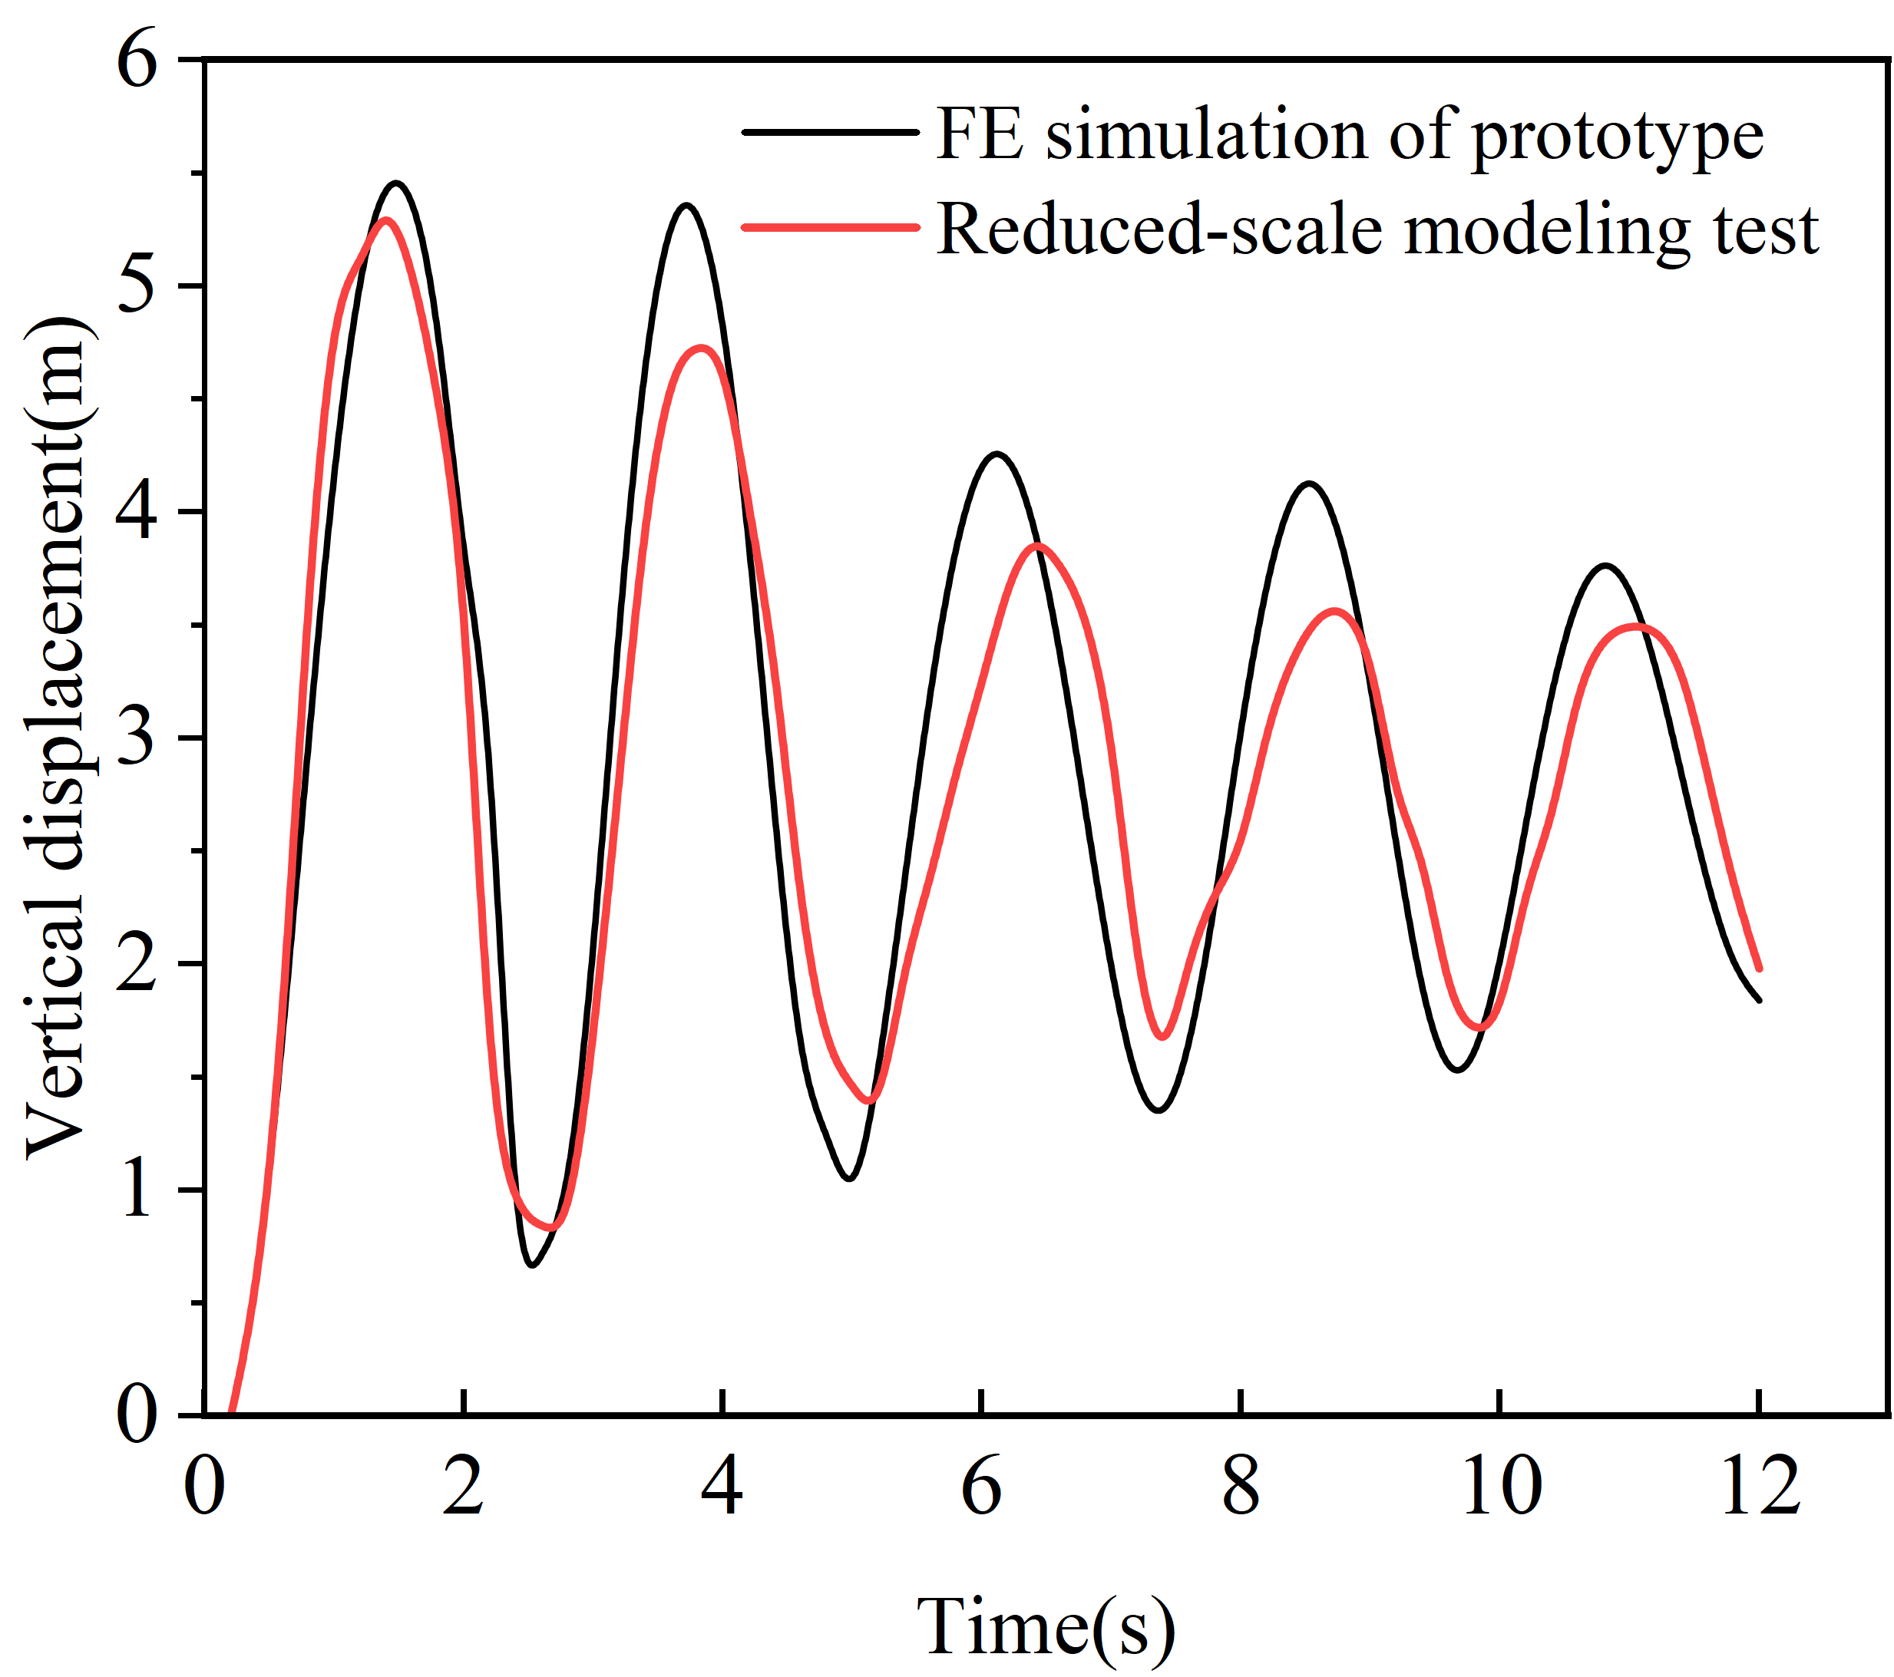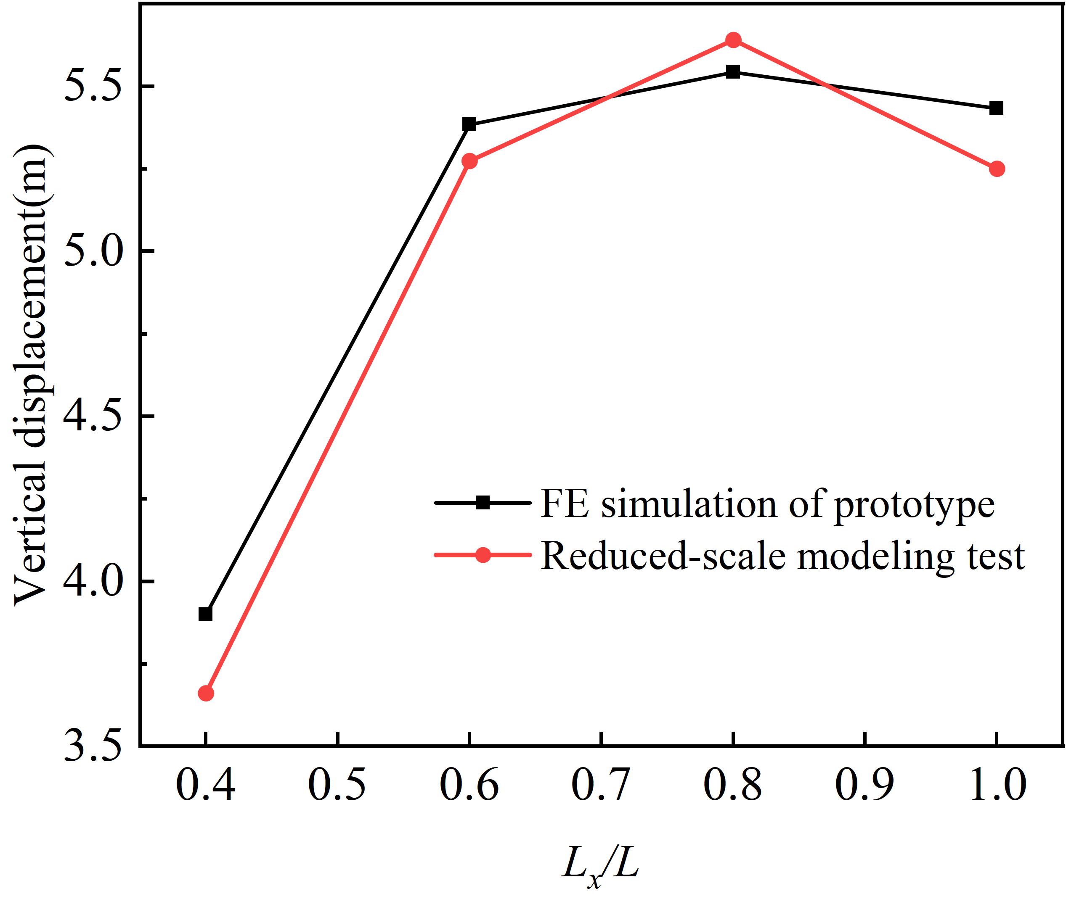
- (b)

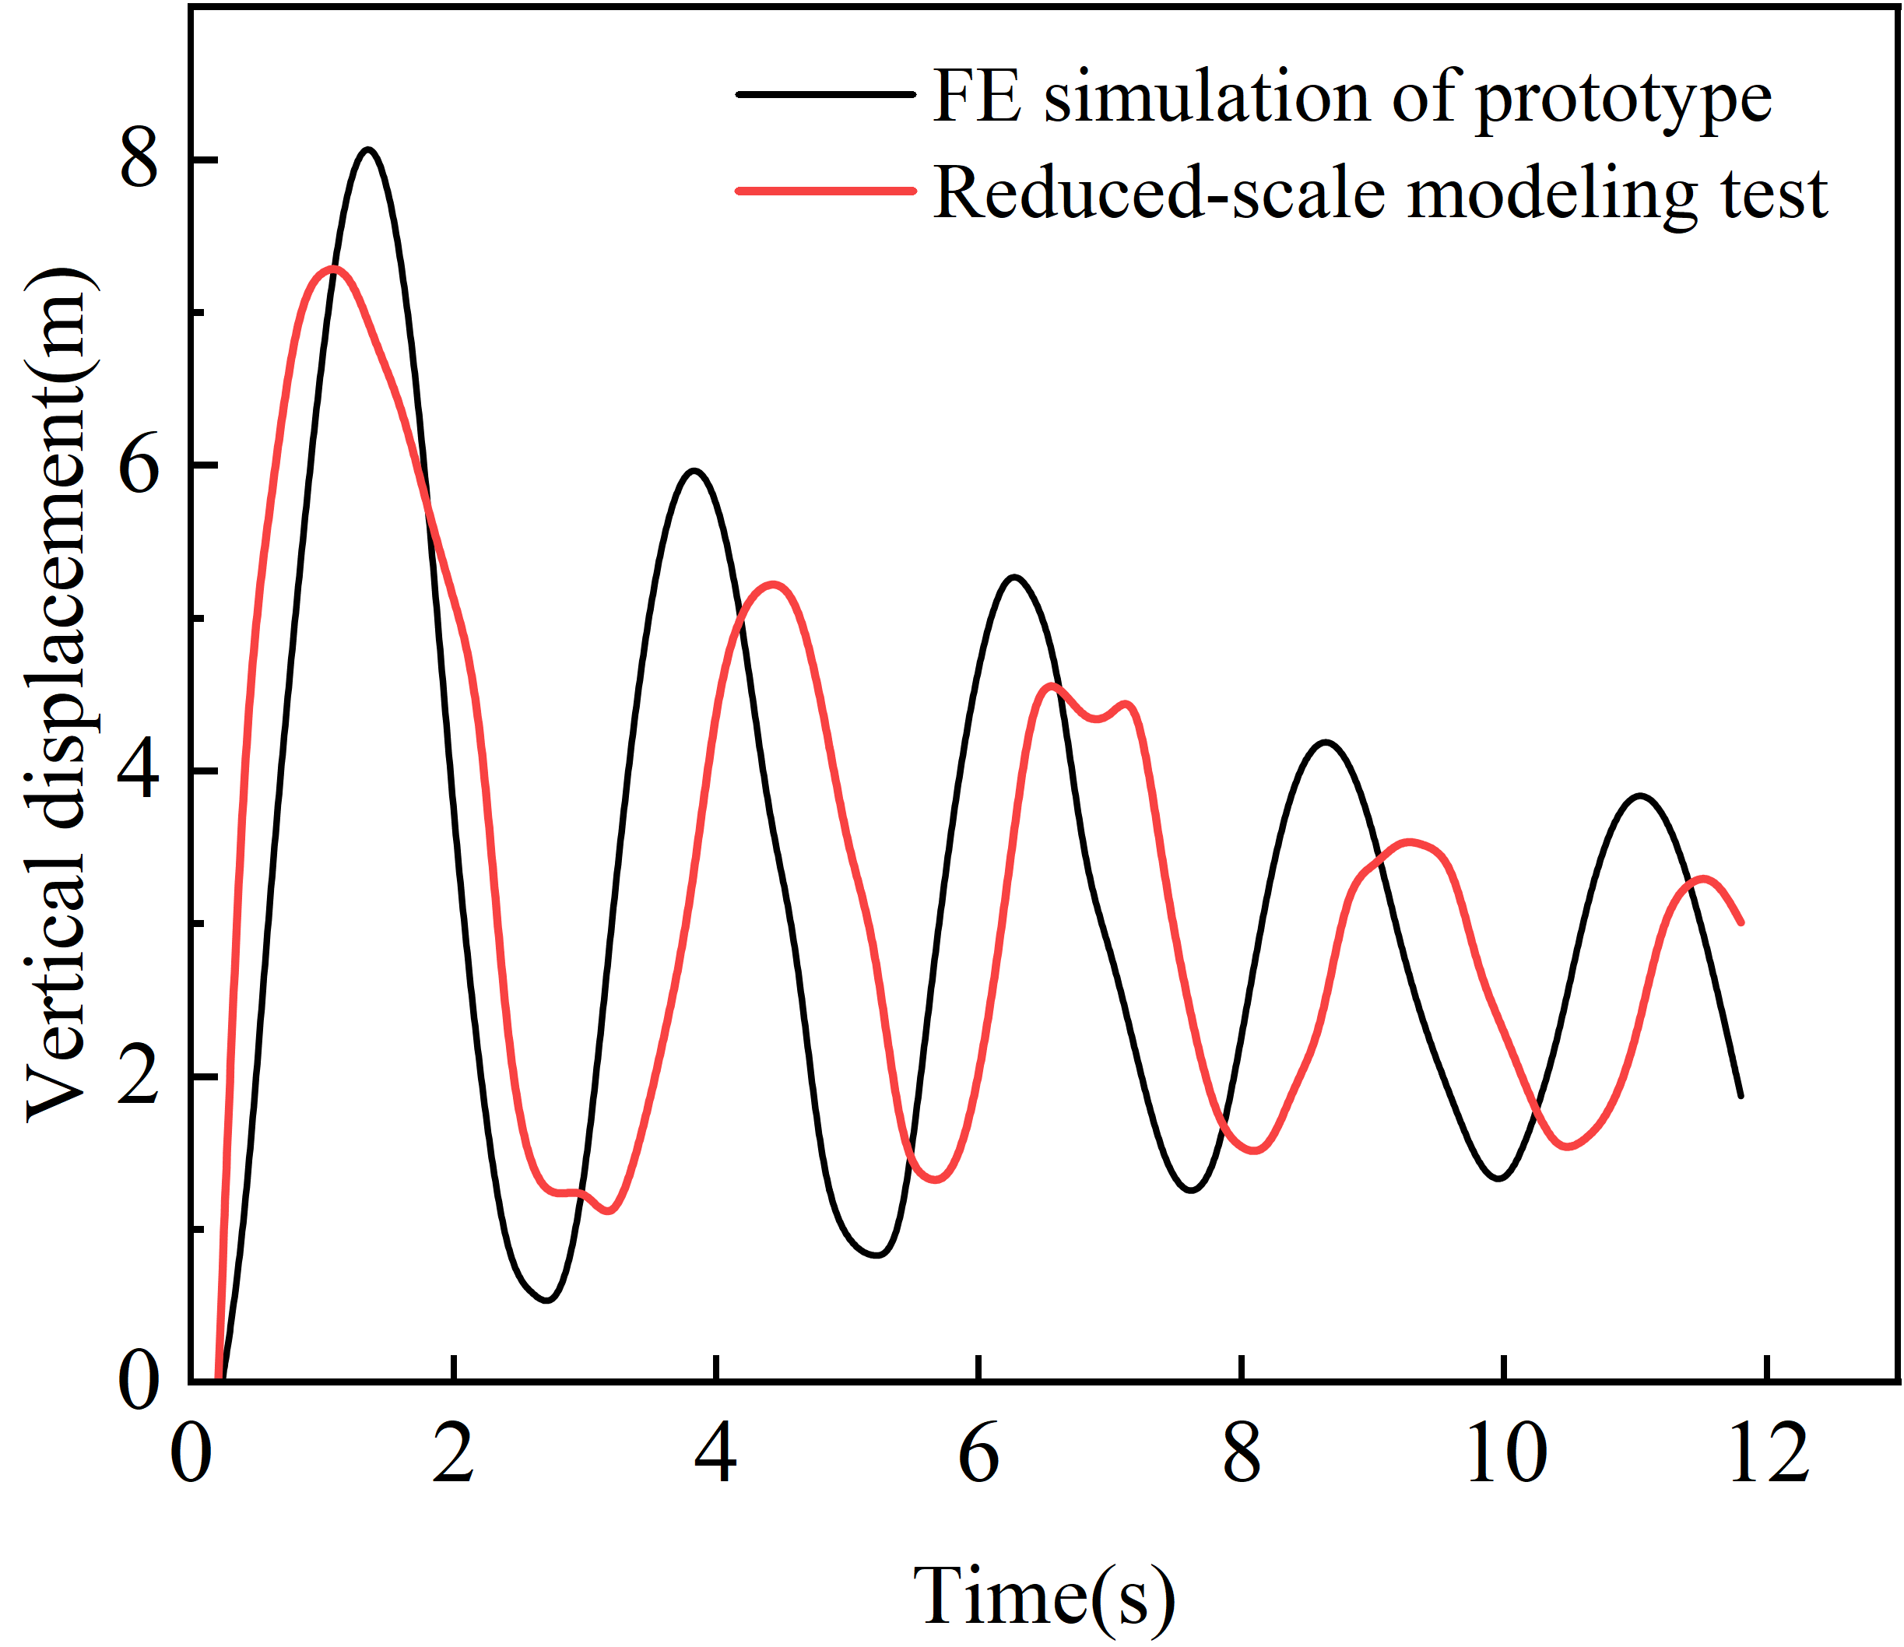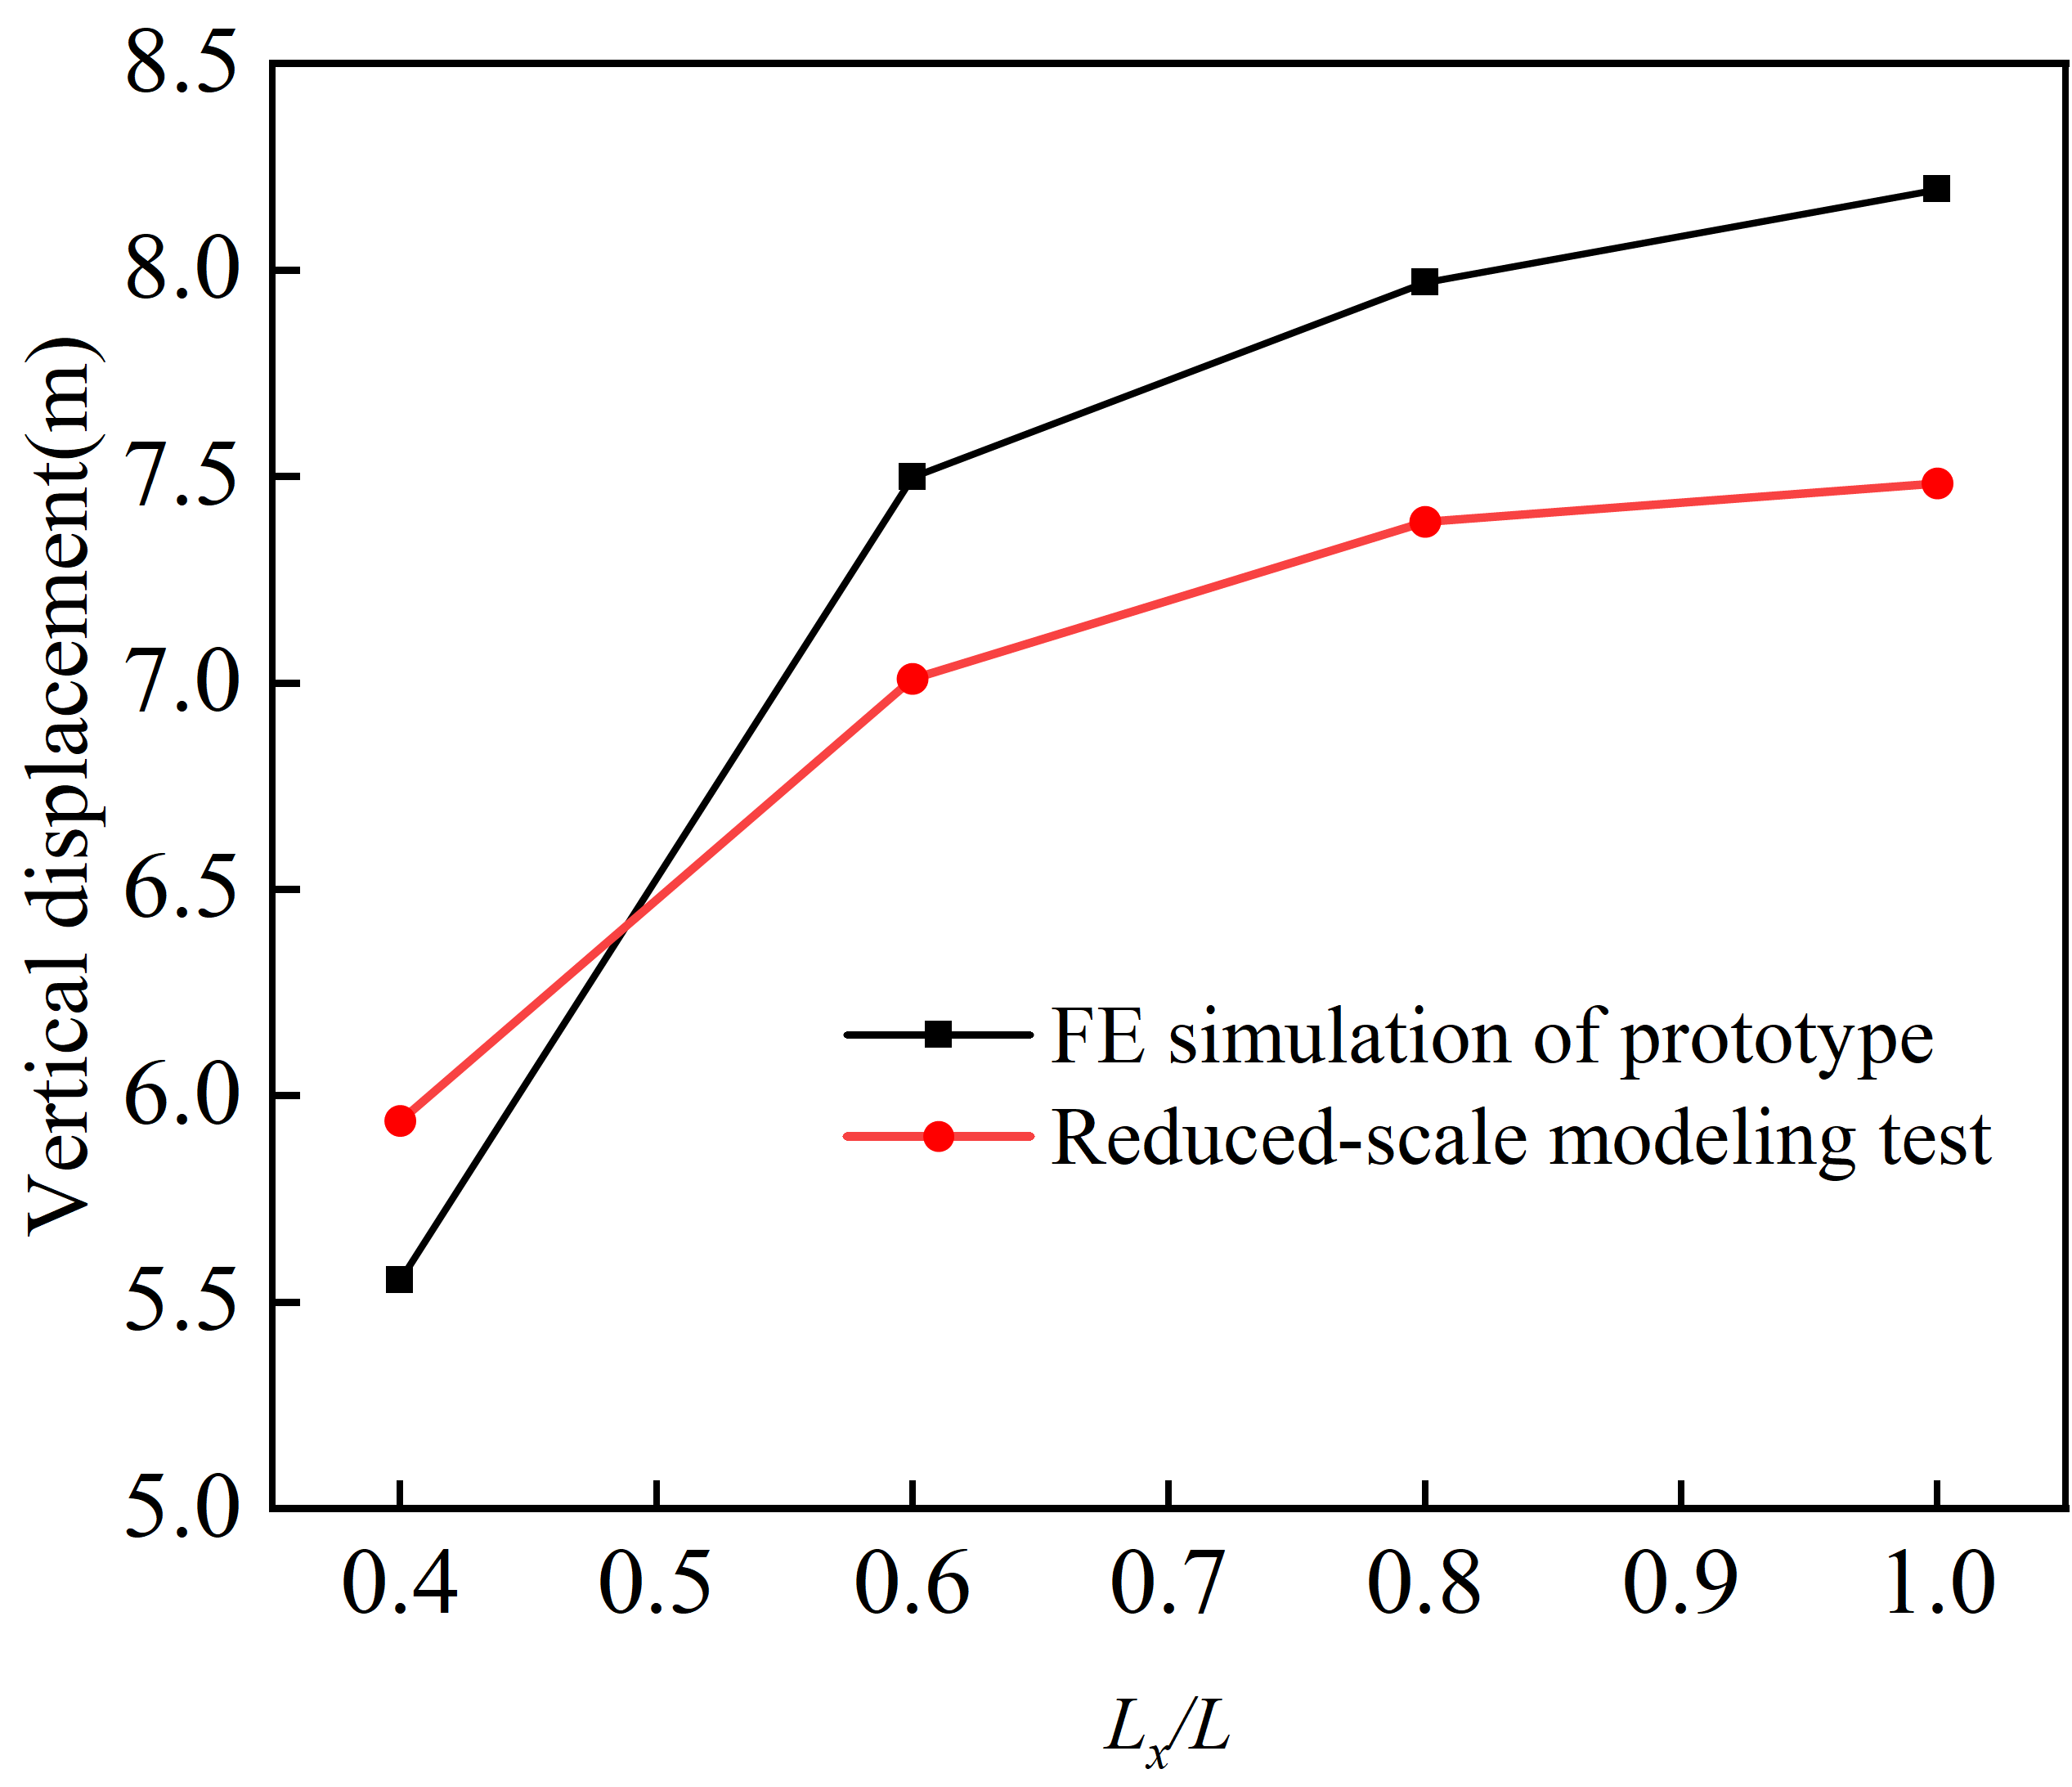
- (d)

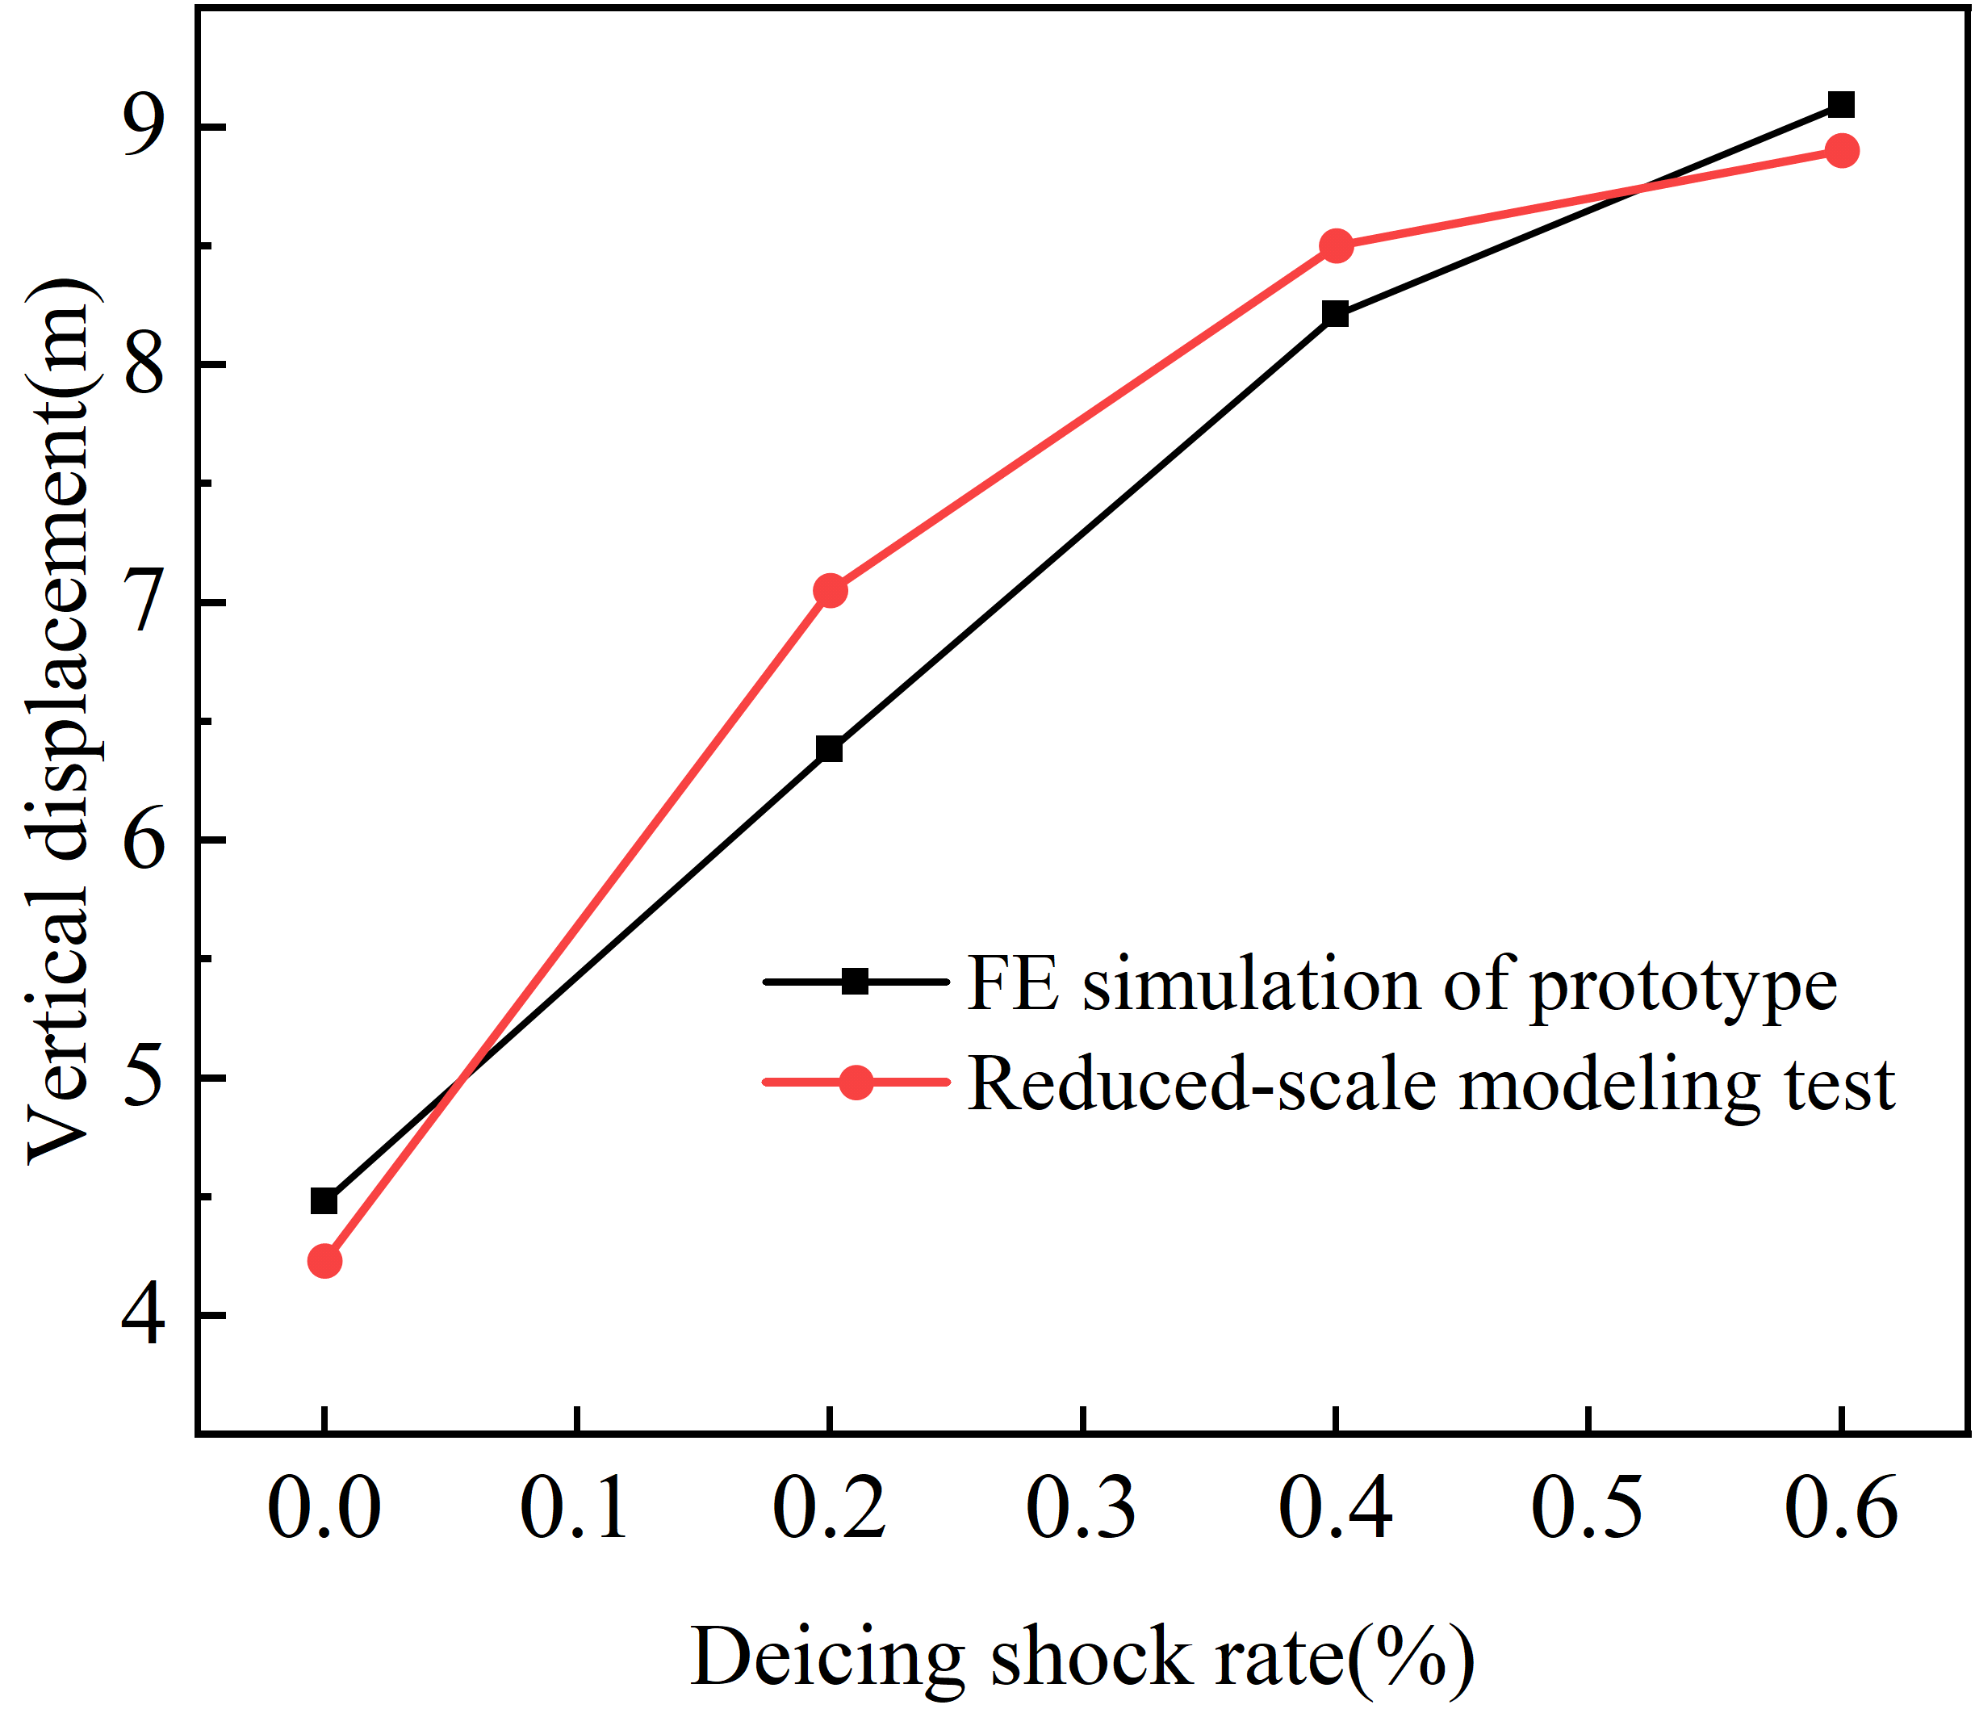
(e)
Fig. 6. Comparison of the jumping heights of the conductors before and after being impacted. (a) Impacted by heavy objects; (b) Not impacted by heavy objects.

Fig. 6(d) is a comparison chart of the maximum jump heights of the conductor under different ice-shedding lengths during the impact of heavy objects, with the maximum relative error being 9.6%. Fig. 6(e) shows the comparison of the maximum jump heights of the experimental and simulated conductors under different ground-wire ice-shedding impact rates. It can be seen that as the ground-wire ice-shedding impact rate increases, the error gradually decreases, with the maximum error being 9.8%. This is probably because when the ice-shedding impact rate becomes larger, the experimental conductor is more fully impacted, resulting in less energy loss.
There are damping differences between numerical simulation and testing, leading to different variation laws of the vibration amplitude for the two. Fortunately, in the first few vibration cycles after the ice cracks, the vertical displacement and tension often reach their maximum values, and at this time, the influence of the damping ratio can be ignored. Since the errors between the maximum jumping heights determined by numerical simulation and those determined by the scaled-down prototype under the above-mentioned multiple situations are all lower than 10%, the proposed numerical modeling method is verified.

Dynamic Response Characteristics of the Transmission Conductor during Ice Shedding under the Impact of Ground-Wire Ice Shedding

Parameters of the Transmission Line and Loads under Full Scale
The dynamic response of transmission lines after ice shedding is mainly influenced by three key factors: the structural parameters of the line itself, the ice-shedding method, and the characteristics of the ground-wire ice-shedding impact (including the impact method and quantity). Since the impact method of ground-wire ice shedding is extremely complex and is affected by various aspects such as the ground-wire ice-shedding method, the amount of ice shedding, and the impact position, in order to simplify the simulation and be more applicable to practical engineering, this paper defines the conductor-ground wire ice-shedding method as synchronous ice shedding without delay, and divides the impact position into median impact and lateral impact, as shown in Fig. 2.
To study the impact effect of ground-wire ice shedding on the ice-shedding jump of conductors, this paper sets the ice accretion thicknesses to be 10, 15, 20, and 25 mm; the single-span lengths are taken as 300, 400, 500, and 600 m respectively; the elevation difference ratios h/L are 0.1, 0.2, and 0.3 respectively; the initial tensions of the conductors are 40, 45, 50, and 55 MPa respectively; the ice-shedding length of the conductor caused by the ground-wire impact L_{x} /L ranges from 0.2 to 1.0, and the ground-wire ice-shedding impact rates are taken as 10%, 20%, 40%, and 60% respectively. A four-bundle conductor is set, and different types of conductors are discussed. Their physical parameters are shown in Table I. With the ice accretion mode being uniform ice accretion, the influence of the ground-wire ice-shedding impact on the conductor jump height under different parameters is calculated.

Dynamic Response Characteristics of the Conductor
To study the influence of the impact effect of ground-wire ice shedding on the ice-shedding jump height of conductors, the ice-shedding dynamic responses of transmission conductors were determined under parameters including a 400 m span, 15 mm ice accretion thickness, no elevation difference, initial tensions of the conductor and ground wire of 50 MPa and 45 MPa, respectively, and a middle-position ground-wire impact. The calculation results are presented in Fig. 7.
It can be concluded that when the ground-wire ice-shedding impact occurs in the middle, as the ground-wire ice-shedding impact rate increases, the jump height of the conductor increases significantly, and its fluctuation becomes more intense. Through analysis, it can be concluded that when the ice shedding impact rate of the ground wire is 20%, due to the occurrence of additional sag, the ice shedding jumping height of the conductor increases by more than 20% under the three working conditions.
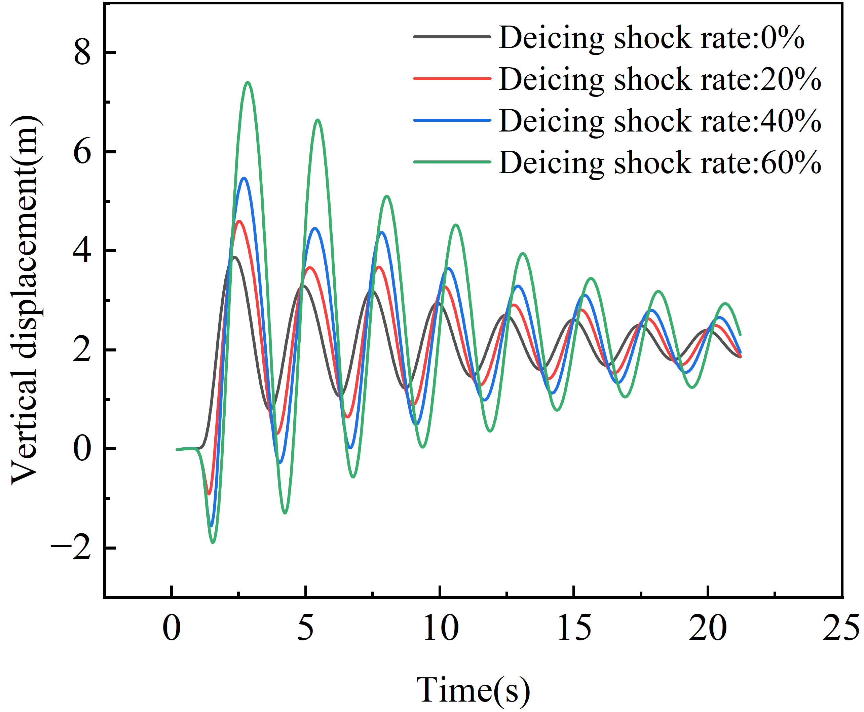
(a)
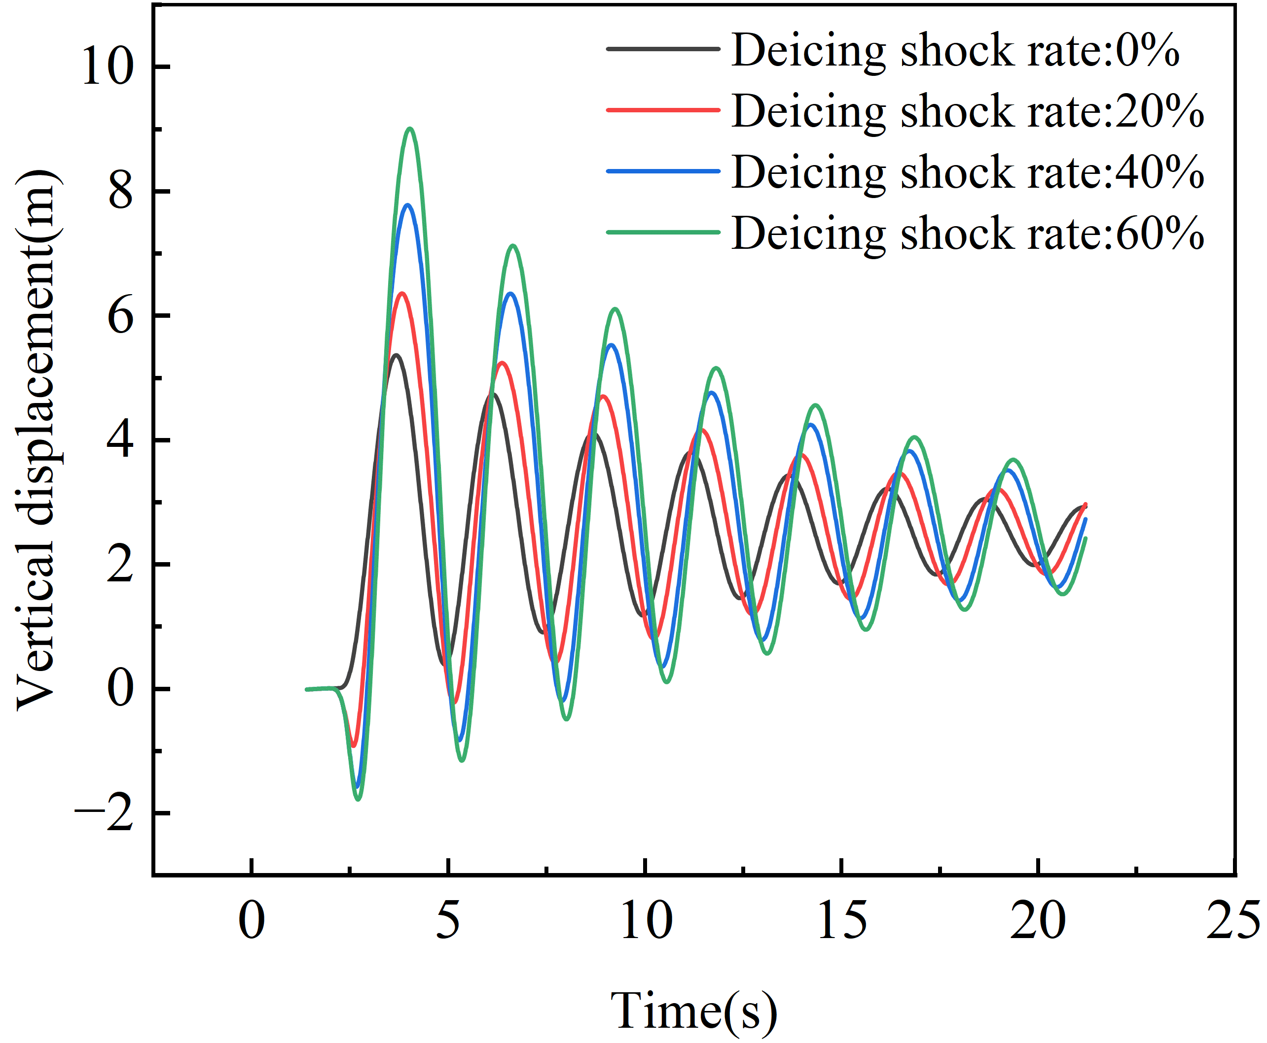
(b)
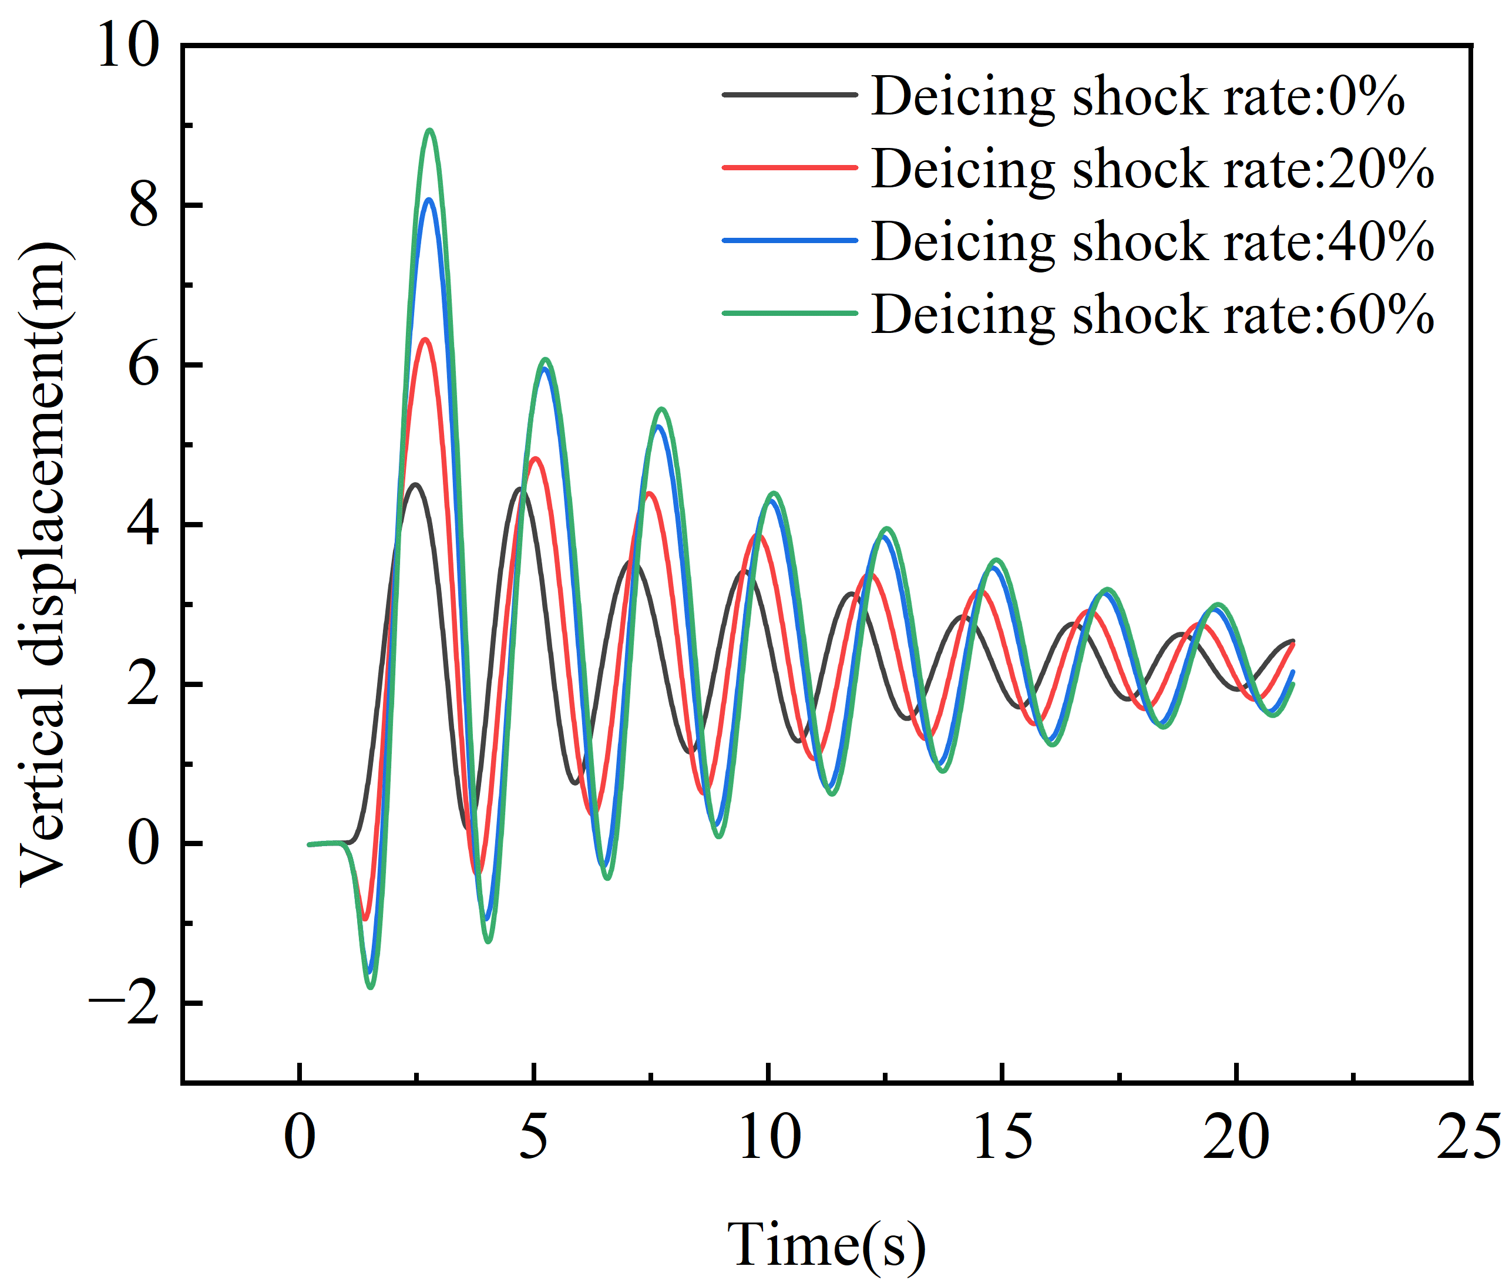
(c)
Fig. 7. The dynamic vertical displacements at typical points for different ice-shedding lengths under median impact after ice shedding. (a) Case 1 L_{x} /L = 0.6; (b)Case 2 L_{x} /L = 0.8; (c)Case 3 L_{x} /L = 1.0.

It can be clearly seen from Fig. 7(c) that this impact has the most significant effect on the full-span ice shedding of the conductor. When the ground-wire ice-shedding impact rate increases from 20% to 60%, compared with the situation without impact, the jump height of the conductor increases by 40.21%, 80.22%, and 98.56%, respectively. As the ground-wire ice-shedding impact rate increases, the growth rate of the conductor's jump height first increases and then decreases. When the ice-shedding length of the conductor L_{x} /L = 0.8, the growth rate of the conductor's jump height shows a roughly proportional relationship with the ice-shedding impact rate. When L_{x} /L = 0.4, the growth rate of the conductor's jump
Height shows a gradually increasing trend with the increase of the ice-shedding impact rate, and when the ground-wire ice-shedding impact rate reaches 60%, the conductor's jump height surges.
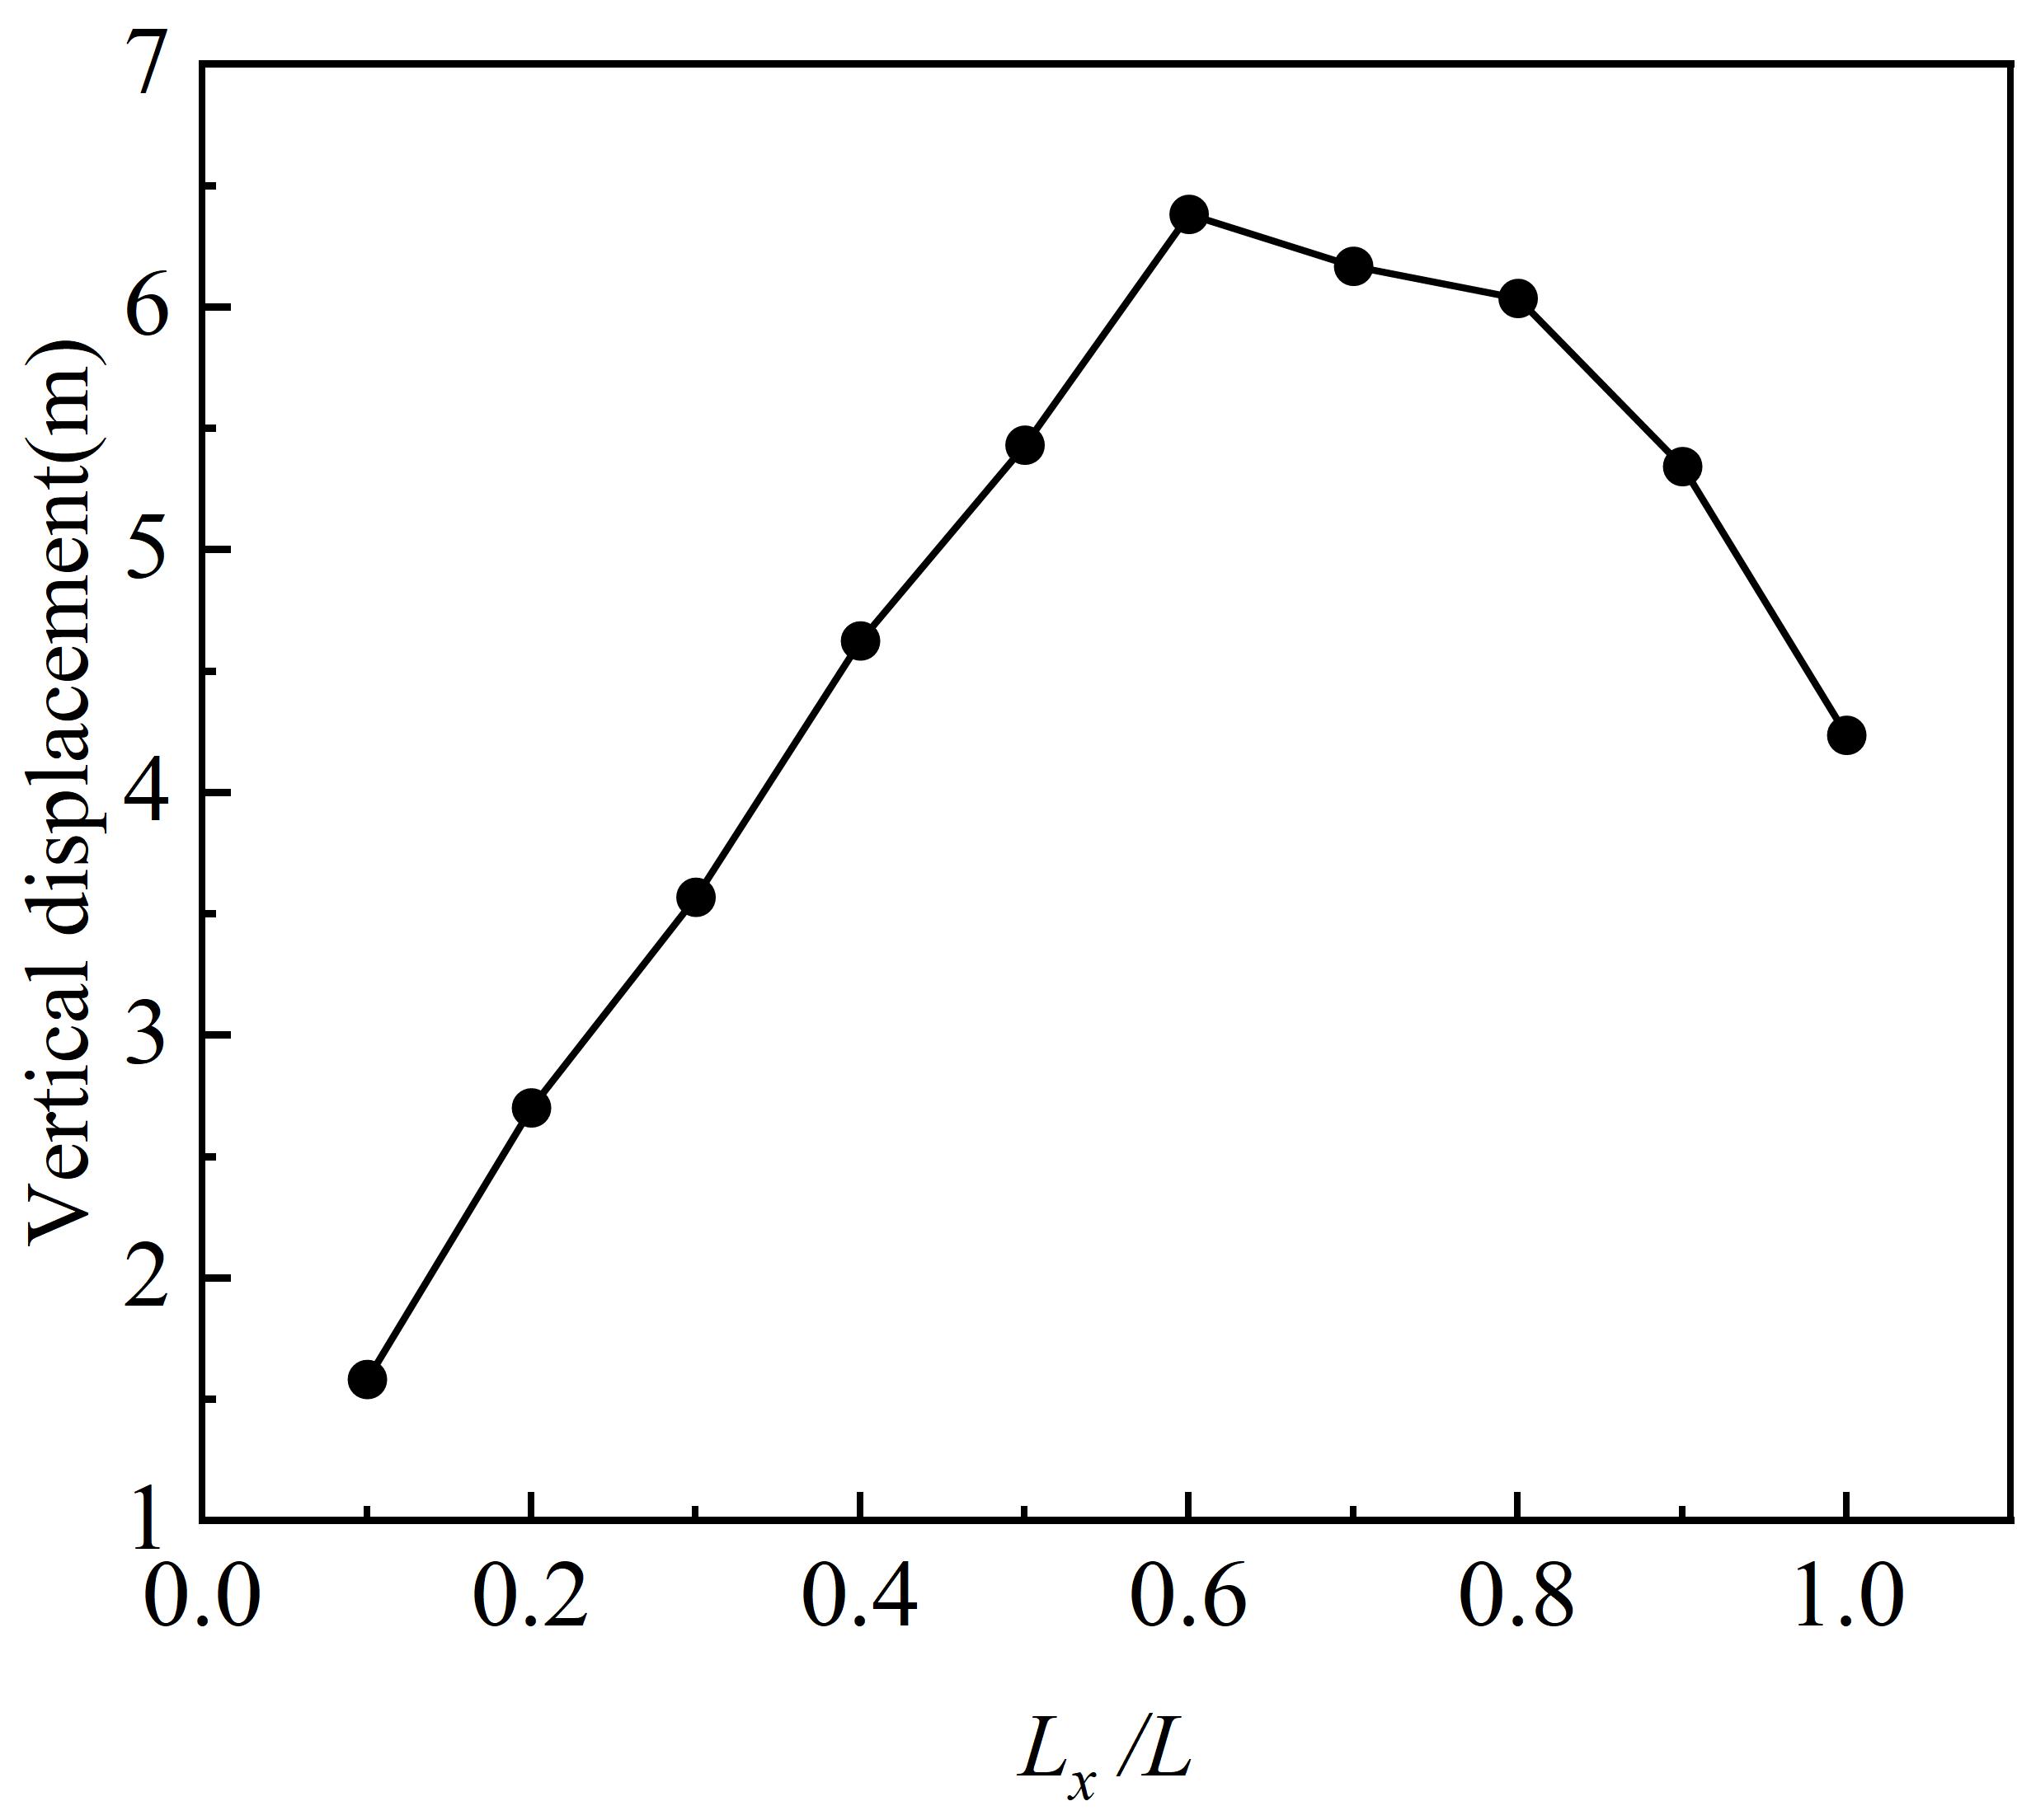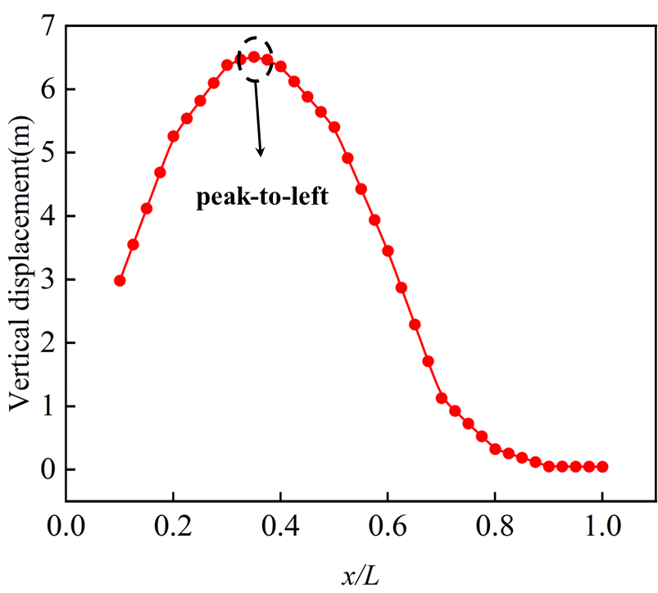
- (b)
Fig. 8. Vertical displacements of typical points of conductors under lateral impact. (a) Variation of jump height with ice-shedding length; (b) Distribution of the jumping heights of each node of the conductor.

To study the influence of the impact position of ground-wire ice shedding on the position of the maximum ice-shedding jump height of the conductor, the impact mode of ground-wire ice shedding is set as lateral impact, and the ground-wire ice-shedding impact rate is set at 20%. The changes in the jump height of the conductor when the ice-shedding length L_{x} /L ranges from 0.1 to 1 are studied respectively. Fig. 8(a) shows the change in the jump height of the conductor as the ice-shedding length increases. It can be seen that when L_{x} /L = 0.6, the jump height of the conductor is the maximum, reaching 6.38 m. As shown in Fig. 8(b), when L_{x} /L = 0.6, the distribution of the jump height of each node of the conductor is presented. The maximum jump height appears at x = 0.312L, instead of at the mid-span. When the conductor experiences full-span ice shedding, the jump height is 4.23 m. Although in this case, the maximum jump occurs at the mid-span, it is lower than the maximum values in other cases. This conclusion is consistent with the numerical simulation research of Wang [15] et al. When there is full-span ice shedding, at least the third-order vibration mode of the conductor will be excited; while when part of the ice accretion sheds, the second-order vibration mode of the conductor is often excited. Moreover, the impact of ground-wire ice shedding on the conductor usually has a greater effect on local ice shedding, which is the reason why the maximum jump height of the conductor under the condition of full-span ice shedding is not the highest.

Parameter Study
In this study, the single-factor control variable method is employed to comprehensively consider the structural and load parameters of the conductors and ground wires of the transmission lines. Based on the differences in the impact position and ice shedding position, finite element simulation research is conducted for multiple parameters such as span length, initial tension stress, conductor type, ice thickness, ice shedding impact rate, and levation difference. Eventually, the dynamic response data of the conductors after the ice shedding impact of the ground wires under different parameter combinations are obtained, and a data set containing thousands of data points is established. These data sets support the fitting of the simplified formulas in the next chapter.
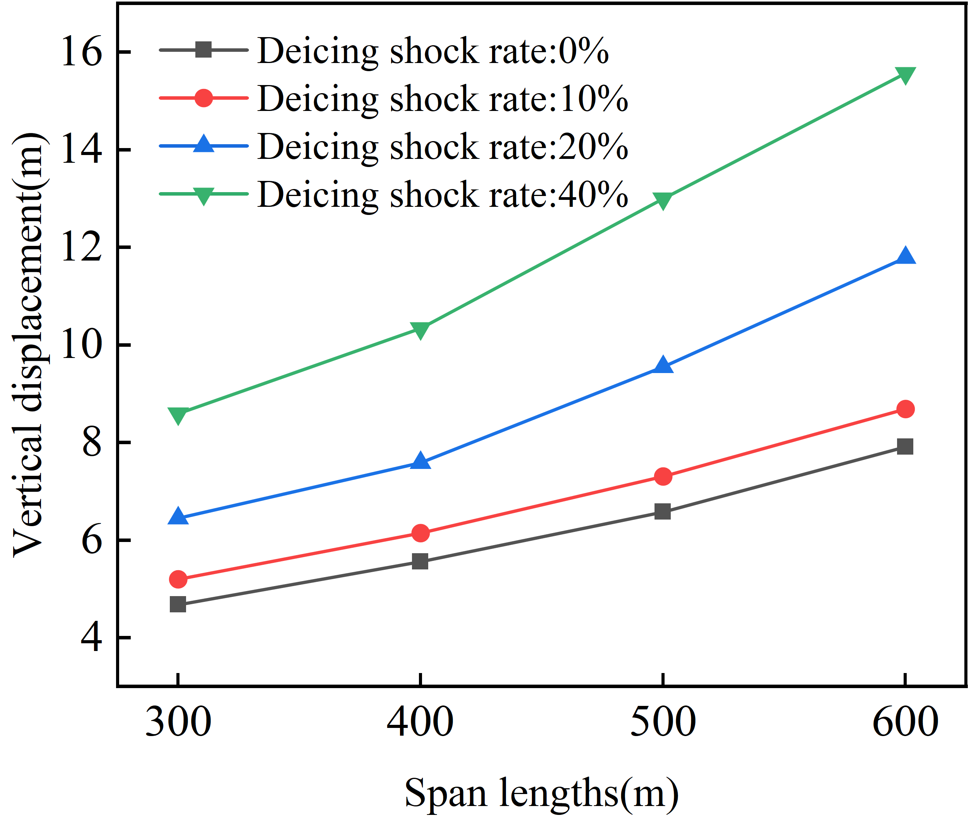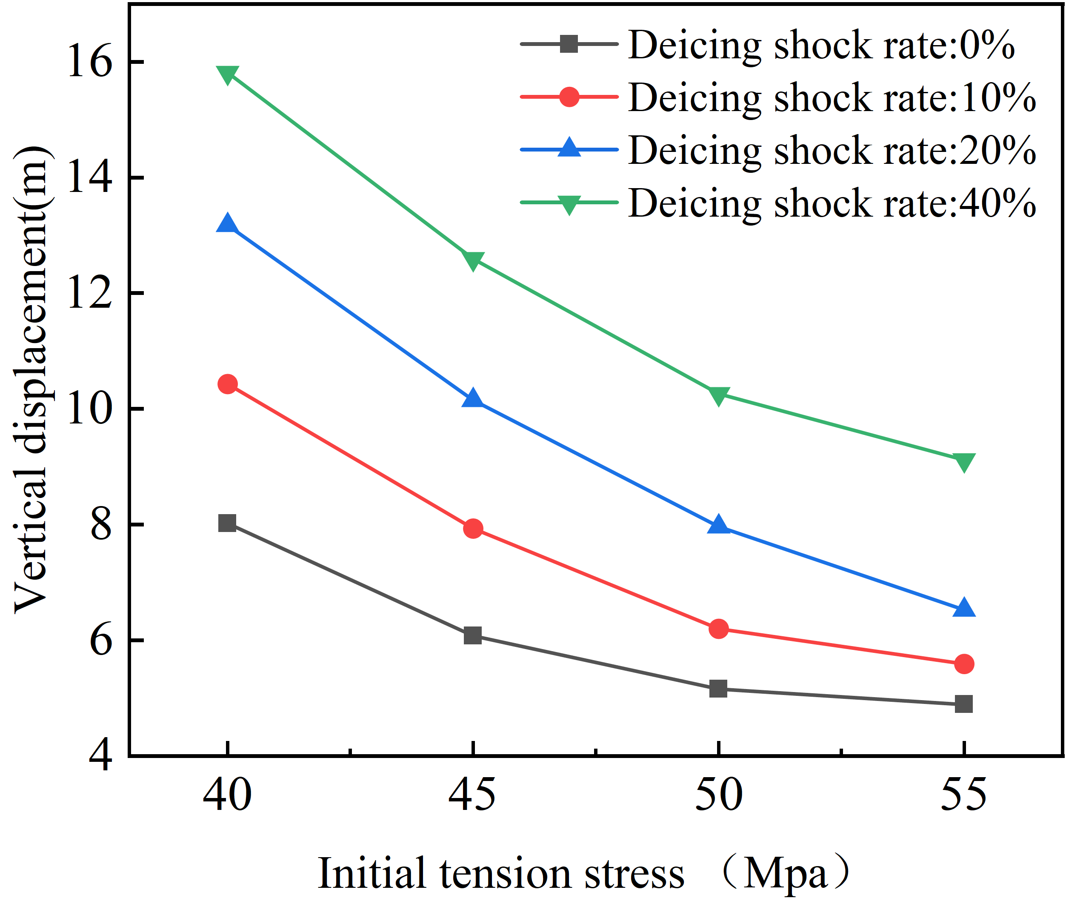
- (b)
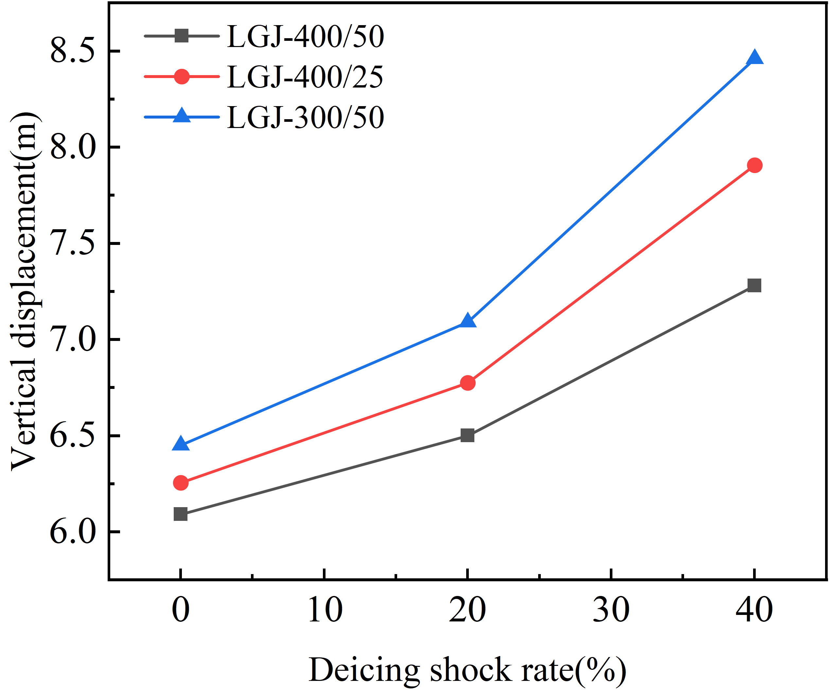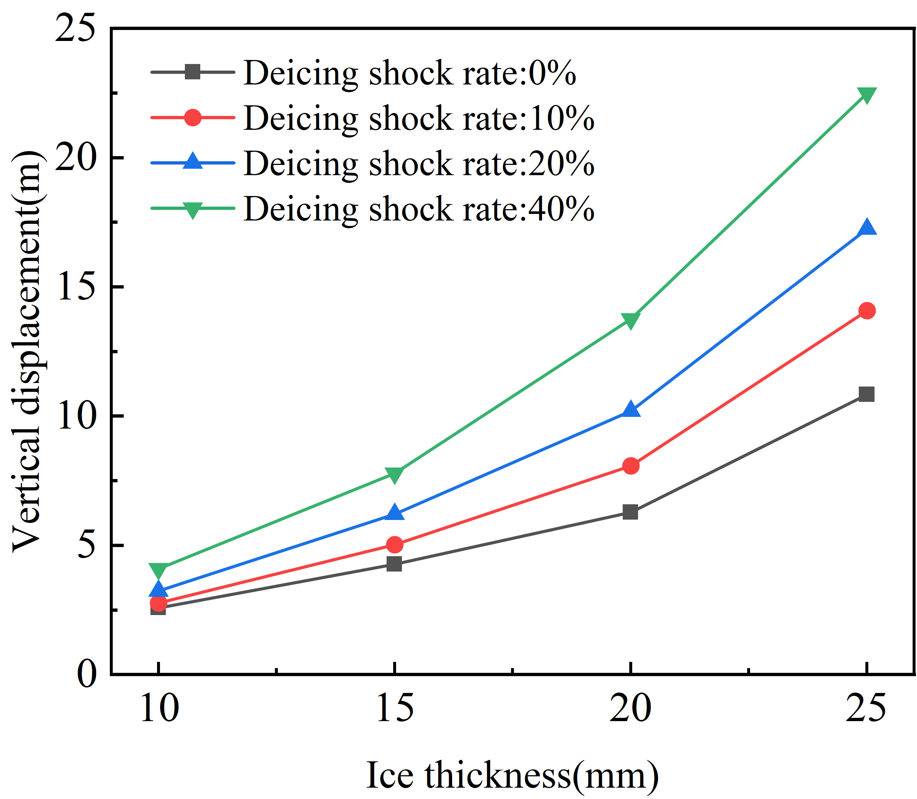
- (d)
Fig. 9. Effect of different parameters of conductors on the vertical displacement under median impact. (a) Effect of Span Length; (b) Effect of Initial Tension Stress; (c) Effect of Conductor Type; (d) Effect of Ice Thickness.

1) Parametric Study on the Conductor's Jumping Height under Median Impact
1. Inﬂuences of Span Length: A four-bundle conductor of LGJ-400/25 is adopted, and the model of the ground wire is JLB-150. The ice accretion thickness of the conductor and the ground wire is 15 mm, and the situation of full-span ice shedding is considered. When the span lengths are 300 m, 400 m, 500 m, and 600 m, respectively, the influence of the ground-wire ice-shedding impact on the ice-shedding jump height of the conductor is studied. As shown in Fig. 9(a), it can be seen that under different impacts, the jump height of the conductor increases with the increase of the span length. Moreover, the higher the ground-wire ice-shedding impact rate is, the greater the growth rate of the jump height with the increase of the span length will be.
2. Inﬂuences of Initial Tension Stress: With a span set at 400 m, no elevation difference, and the conductor types as described in Table I for other parameters, the changes in the conductor jump height with the initial tension under different ground-wire ice-shedding impacts are shown in Fig. 9(b). It can be observed that when the ground-wire impact rates are different, the conductor jump height decreases significantly with the increase of the initial stress. In addition, the increase in the initial tension will greatly weaken the impact effect of ground-wire ice shedding.
3. Inﬂuences of Conductor Type: When the span is 400 m and the situation of full-span ice shedding occurs, with the conductor types referring to Table I, Fig. 9(c) shows that as the ground-wire ice-shedding impact increases, different conductor models have a significant influence on the conductor jump height. It can be seen that the differences in the cross-sectional area and stiffness of the conductor are the
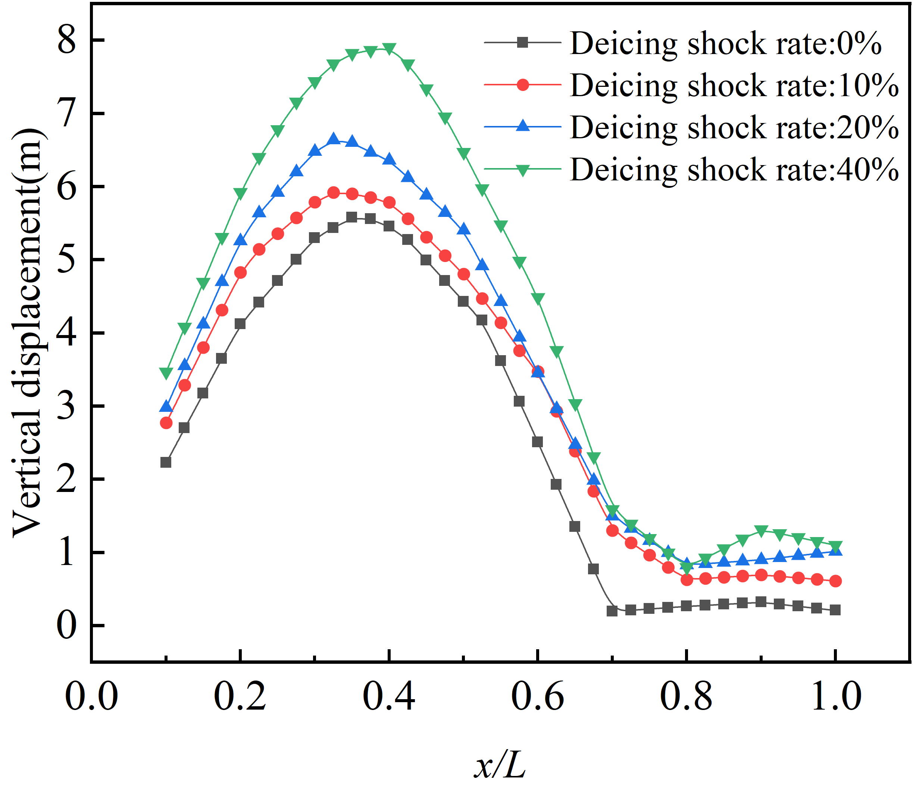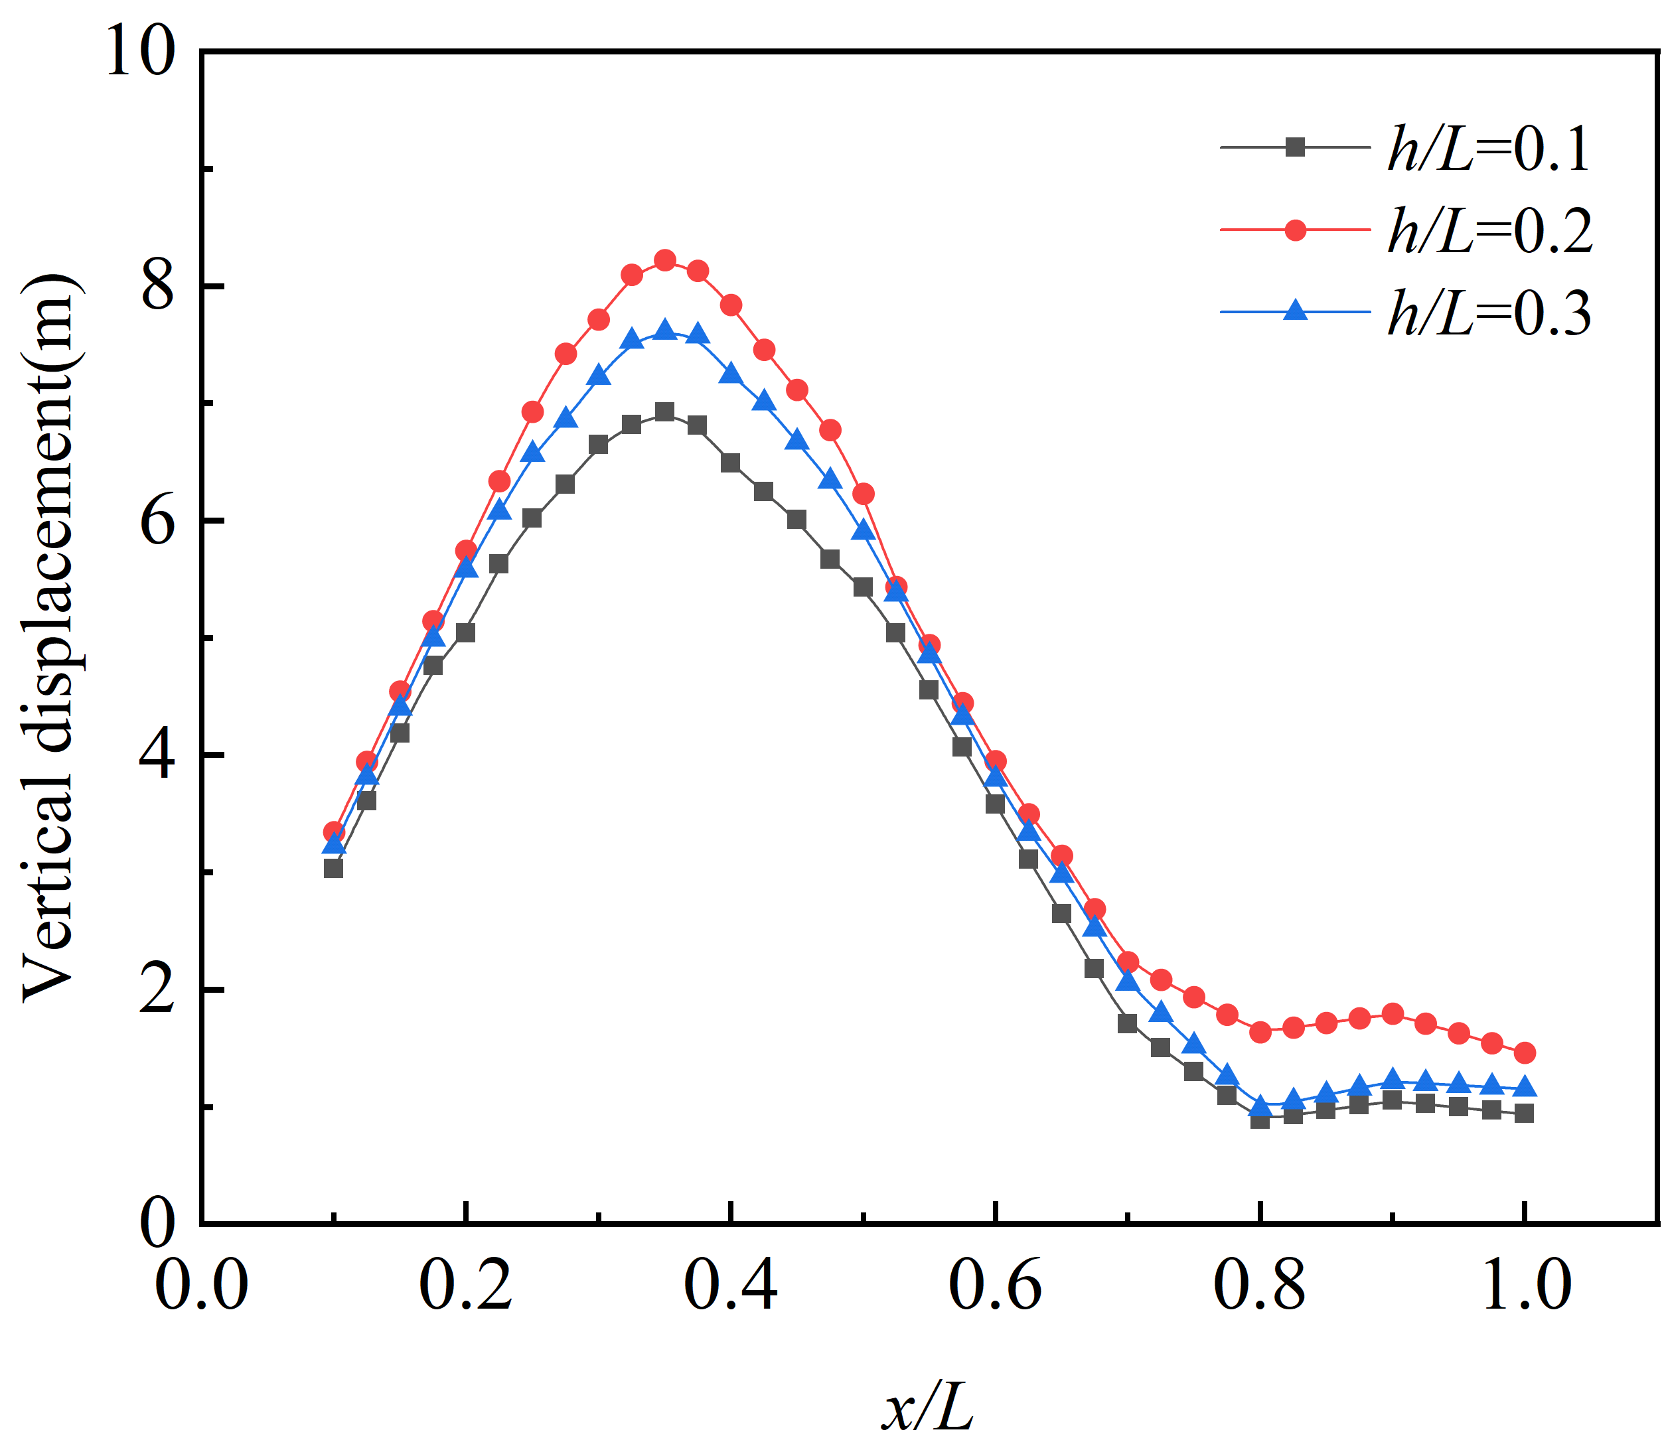
- (b)

Fig. 10. Effects of different parameters of conductors on their vertical displacements under lateral impact. (a) Effect of the ice shedding impact rate of the ground wire; (b) Effect of Elevation Difference.

main influencing factors. On the other hand, the increase in the conductor diameter will lead to an increase in the ice accretion load, and at the same time, it will make the ice-shedding jump height larger.
4. Inﬂuences of Ice Thickness: For the LGJ-400/25 conductor, with a span of 400 m and an initial tension of 50 MPa, as shown in Fig. 9(d), it demonstrates the influence of the ice accretion thickness on the conductor's ice-shedding jump under different ground-wire ice-shedding impacts. It can be seen that the conductor jump height increases with the increase of the ice accretion thickness, and as the ice accretion thickness grows larger, the influence of the ground-wire ice-shedding impact increases linearly.
2) Parametric Study on the Conductor's Jumping Height under Lateral Impact
1. The Influence of the Ice Shedding Impact Rate of the Ground Wire: A four-bundle conductor of LGJ-400/25 is adopted, and the ground wire model is JLB-150. With a span of 400 m, an initial tension of 55 MPa, and the ice-shedding length of the conductor L_{x} /L = 0.6, Fig. 10(a) shows the distribution of the conductor jump height with the change of the ground-wire ice-shedding impact rate. It can be seen that as the ice-shedding impact rate increases, the ice-shedding jump height of the conductor rises linearly, and the point of the maximum jump height of the conductor gradually approaches the impact position. When the ground-wire ice-shedding impact rate exceeds 20%, the growth rate of the conductor jump height caused by it will be even greater.
2. Inﬂuences of Elevation Difference: A span of 400 m and an ice accretion thickness of 20 mm are set to analyze the influence of the side-position impact of ground-wire ice shedding on the ice-shedding jump height of the conductor under different elevation differences. Fig. 10(b) shows the distribution of the conductor jump height under different elevation difference ratios h/L when the conductor is subjected to a 20% ice-shedding impact rate. The results show that as the elevation difference ratio increases, the conductor jump height first increases and then decreases, and the jump height reaches the maximum when h/L=0.2.

Formula for the jumping height of transmission line ice shedding due to ground wire ice shedding impact

Simplified Jump Height Formula
In the design of transmission lines, an effective calculation formula for the ice-shedding jump height is of great help to the line design. Through the summary of experimental and numerical simulation data, this paper finally obtains, by fitting, a calculation formula for the ice-shedding jump height of conductors under the impact effect of ground-wire ice shedding, and conducts an error analysis. Currently, common empirical formulas can be found in reference [17].
(3)
where H is the maximum jump height of the conductor, L is the span length, m is a factor within the range of 0.5 to 0.9 that reflects the effect of partial ice shedding, and $Δf$ is the difference in the sag of the conductor before and after ice shedding.
The above formula can predict the ice-shedding jump height of the conductor, but it does not take into account the jump height of the transmission conductor after being affected by the impact effect of ground-wire ice shedding. Therefore, based on the experimental data of the reduced-scale and the results obtained from numerical simulations, this paper uses the least squares method to fit the formula for the ice-shedding jump data, and proposes a formula for calculating the ice-shedding jump height of the conductor under the impact of ground-wire ice shedding for spans within 600 m. It is shown as follows:
(4)
(5)
where $Δf_{all}$ is the sum of the difference in the sag of the conductor before and after ice shedding and the additional sag generated after being impacted. $Δf_{0}$ is the difference in the sag of the conductor before and after ice shedding without being impacted. $Δf(k)$ is obtained by fitting using linear regression, representing the additional sag generated in the conductor after being impacted by the ground-wire ice shedding, as shown in Formula (6).
(6)
where k is the ground-wire ice-shedding impact rate, which corresponds to Formula (1) in the first section.

Discussion on the Suitability of the Jump Height Formula
A span of 400 m is set, and error analyses are carried out on the results of the maximum ice-shedding jump heights with ice accretion thicknesses of 10, 15, 20, and 25 mm, respectively, so as to verify the mathematical models under the conditions.
With and without the impact effect of ground-wire ice shedding. As shown in Fig. 11, it can be observed that the relative error of the conductor jump height without impact is within 4.7%. After the conductor is impacted by the ground-wire ice shedding, its jump height is higher, and the potential hazard is greater, with the relative error within 6.6%.
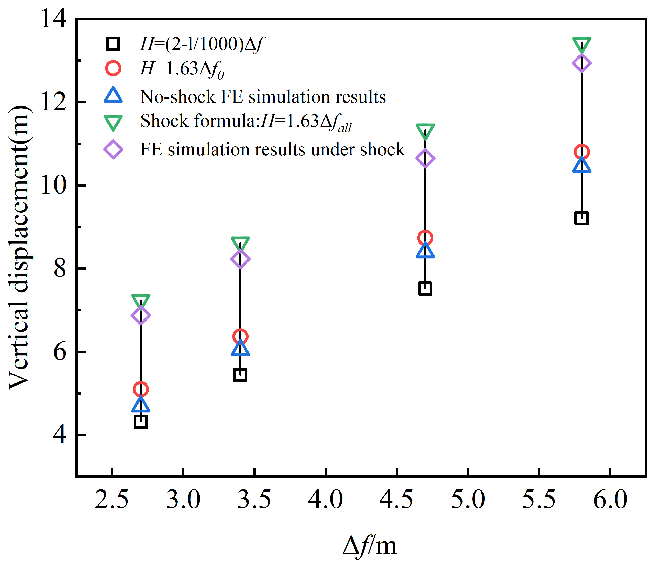
Fig. 11. The jumping heights determined by the finite element and mathematical models.

Therefore, Formulas (5) and (6) can be applied to calculate the jump height of the conductor after being impacted by the ground-wire ice shedding, which is of great significance for the engineering design of transmission lines.

Conclusion
This paper, for the first time, proposes a numerical modeling method for the dynamic response of conductors during ice shedding under the impact of ice shedding from ground wires. According to the similarity principle, a reduced-scale test model of the double-layer ice shedding system of conductors and ground wires is established, and mutual verification between the simulation and the test is carried out. Using this model, the dynamic response analysis of conductors after the impact of ice shedding from ground wires under different parameters is conducted. Based on the research data, a simplified formula for the jumping height of conductors during ice shedding under the impact of ice shedding from ground wires is fitted and obtained. The conclusions are as follows:
1) The ice shedding impact of ground wires can be categorized into median impact and lateral impact. Among them, under the median impact of ground wire ice shedding, the jumping height of the conductors is higher. Compared with partial ice shedding, when ice shedding occurs across the entire span under different ice shedding impact rates, the increase in the take-off height of the conductors is more significant, even reaching over 40%.
2) The jumping height of the conductors with a small amount of partial ice shedding (L_{x}/L = 0.4) is more sensitive to the ice shedding impact of ground wires. When the ice shedding impact rate of ground wires is 60% (which is greater than the ice shedding amount of the conductors), it will trigger a sharp surge in the growth rate of the conductors' jumping height.
3) The vibration complexity after the lateral ice shedding impact of ground wires is higher. When partial ice shedding occurs on the conductors, the maximum ice shedding jumping point is not at the mid-span of the conductors. When the conductors are not affected by the ice shedding impact of ground wires, the maximum jumping point is near the middle position of the ice shedding section. However, when the conductors are affected by the ice shedding impact of ground wires, the maximum ice shedding jumping point appears near the area of the impact point.
4) Through the parametric study on the ice shedding impact of ground wires, it is found that the influence degree of the ice shedding impact rate on the jumping height of the conductors is closely related to the span, initial tension and ice thickness, while the changes of the conductor type and height difference have relatively little impact on it.
5) By introducing the additional sag, a formula for the jumping height of the transmission conductors after being impacted by the ice shedding of ground wires is fitted. This formula can be used for the rapid prediction of the jumping height of the conductors under the ice shedding impact of ground wires, which has important engineering value for the design, operation, and maintenance of the transmission lines.

References

- M. Farzaneh and W. A. Chisholm, Insulators for Icing and Polluted Environments. Hoboken, NJ: Wiley/IEEE Press, 2009.
- H. Yi, “Analysis and countermeasures discussion for large area icing accident on power grid,” High Voltage Eng., vol. 34, pp. 215–219,2008.
- G. McClure and M. Lapointe, “Modeling the structural dynamic response of overhead transmission lines,” Comput. Structures, vol.81, pp 825–834, 2003.
- F. Mirshafiei, G. McClure, and M. Farzaneh, “Modelling the dynamic response of iced transmission lines subjected to cable rupture and iceshedding,” IEEE Trans. Power Del.., vol. 28, no. 2, pp. 948–954, Apr.2013.
- F. Yang, J. Yang, Z. Zhang, H. Zhang, and H. Xing, “Analysis on the dynamic responses of a prototype line from iced broken conductors,” Eng. Fail. Anal., vol. 39, pp. 108–123, 2014.
- V. T. Morgan and D. A. Swift, “Jump height of overhead-line conductors after the sudden release of ice loads,” Proc. Inst. Elect. Engineers, vol. 111, no. 10, pp. 1736–1746, 1964.
- A. Jamaleddine, G. McClure, J. Rousselet, and R. Beauchemin, “Simulation of ice shedding on electrical transmission lines using ADINA,” Comput. Struct., vol. 47, no. 4/5, pp. 523–536, 1993.
- P. V. Dyke, D. Havard, and A. Laneville, “Effect of ice and snow on the dynamics of transmission line conductors,” in Atmospheric Icing of Power Networks. Berlin, Germany: Springer, 2008, pp. 171–228.
- M. R. Fekr and G. McClure. “Numerical modelling of the dynamic response of ice shedding on electrical transmission lines”. Atmospheric Res., Vol. 46, No. 1/2, pp. 1–11, 1998.
- F. Mirshafei, G. McClure, and M. Farzaneh, “Modelling the dynamic response of iced transmission lines subjected to cable rupture and Ice shedding,” IEEE Trans. Power Del.., vol. 28, no. 2, pp. 948–954, Apr. 2013.
- B. Yan, K. Chen, Y. Guo, M. Liang, and Q. Yuan, “Numerical simulation study on jump height of iced transmission lines after ice shedding,” IEEE Trans. Power Del.., vol. 28, no. 1, pp. 216–225, Jan. 2013.
- Y. Xie, L. Huang, D. Wang, H. Ding, and X. Yin, “Modeling and analysis of progressive ice shedding along a transmission line during thermal deicing,” Math. Problems Eng., vol. 2019, 2019, Art. no. 4851235.
- T. Kalman, M. Farzaneh, and G. McClure, “Numerical analysis of the dynamic effects of shock-load-induced ice shedding on overhead ground wires,” Comput. Struct., vol. 85, pp. 375–384, 2007.
- F. Mirshafiei, “Modelling the dynamic response of overhead line conductors subjected to shock-induced ice shedding,” M.Eng. thesis, Dept.Civil Eng. Appl. Mech., McGill Univ., Montreal, QC, Canada, 2010.
- L. Wang, L. Cao, Y. Gao, Q. Wang, and Q. Li, “Law of sever conditions of non-uniform ice-shedding jumping of transmission lines,” High Voltage Eng., vol. 44, no. 08, pp. 2442–2449, 2018.
- K. Ji, X. Rui, L. Li, A. Leblond, and G. McClure, “A novel ice-shedding model for overhead power line conductors with the consideration of adhesive/cohesive forces,” Comput. Struct., vol. 157, pp. 153–164, 2015.
- K. Ji, X. Rui, L. Li, F. Yang, and G. McClure, “Dynamic response of iced overhead electric transmission lines following cable rupture shock and induced ice shedding,” IEEE Trans. Power Del.., vol. 31, no. 5, pp. 2215–2222, Oct. 2016.
- K. Ji, B. Liu, Y. Dong, X. Rui, and G. McClure, “Dynamic analysis of Multi-span overhead electric transmission line considering induced ice shedding,” in Proc. Int. Workshop Atmospheric Icing Struct., 2017, p. 5.
- K. Ji, X. Rui, L. Li, C. Zhou, C. Liu, and G. McClure, “The time-varying characteristics of overhead electric transmission lines considering the induced-ice-shedding effect,” ShockVib., vol. 2015, 2015, Art. no. 635230.
- H. Oertli, “Oscillations de cables electriques aeriens apres la chute desurcharges,” Bull. Assoc. Suisse Elect., vol. 41, p. 501, 1950.
- K. Lips, “Die Schnellhohe von Freileitungsseilen nach Abfallen von Zusatzlastcn,” Bull. Assoc. Suisse Elect., vol. 43, p. 62, 1952.
- V. List and K. Pochop, Mechanical Design of Overhead Transmission Lines. Prague, Czechoslovakia: SNTL Publisher of Technical Literature, 1963.
- Design Manual of High Voltage Transmission Lines for Electric Engineering. Beijing, China: China Electric Power Press, 2003, pp.173–176, (in Chinese), Northeast Electric Power Design Inst. Nat. Elect. Power Corp., p. 116.
- F. L. Yang, J. B. Yang, J. K. Han, and D. J. Fu, “Dynamic responses of transmission tower-line system under ice shedding,” Int. J. Struct.Stability Dynam., vol. 10, no. 3, pp. 461–481, 2010.
- Wang Xinmin. Structural Dynamic analysis and application with ANSYS [M]. Beijing: China Communications Press, 2015.
- M. R. Fekr and G. McClure, “Numerical modelling of the dynamic response of ice shedding on electrical transmission lines,” Atmospher.Res., vol. 46, pp. 1–11, 1998.
- T. Kálmán, M. Farzaneh, and G. McClure, “Numerical analysis of the dynamic effects of shock-load-induced ice shedding on overhead ground wires,” Comput. Struct., vol. 85, no. 7/8, pp. 375–384, 2007.
- E. Kim, "Experimental and numerical studies related to the coupled behavior of ice mass and steel structures during accidental collisions," Norwegian University of Science and Technology, Trondheim, Norway, Ph.D. dissertation, 2014.
- W. Cai, L. Zhu, and L. Bi Z, “Prediction method for plastic dynamic response of hull plate subjected to ice floe impact,” Chinese Journal of Ship Research, vol.16, no.05, pp 95–100,2021.
- G. Huang, B. Yan, N. Wen, C. Wu, and Q. Li, “Study on jump height of transmission lines after ice-shedding by reduced-scale modeling test,” Cold Regions Sci. Technol., vol. 165, 2019, Art. no. 102781.

Jian Wang was born in Shandong, China, in 1985. He received the B.S. and M.S. degrees from Shandong University, Jinan, China, and the Ph.D. degree in High Voltage and Insulation Technology from North China Electric Power University, Beijing, China. In 2021, he joined North China Electric Power University. He is currently a Professor with research interests in the dynamic response of transmission lines and online monitoring of insulation defects in electrical equipment.

Leijie Liu was born in Anhui, China, in 1999. He is currently working toward the M.Eng. degree in electrical engineering with North China Electric Power University, Beijing, China. His research interests include engineering mechanics and the dynamic response of transmission lines.


Xianfeng Li was born in Shandong, China, in 1996. He received the M.S. degree in electrical engineering from North China Electric Power University, Baoding, in 2022. He is currently working toward the Ph.D. degree in electrical engineering at North China Electric Power University, Beijing, China.
His research interests include engineering mechanics and the dynamic response of transmission lines.


Nan Chen was born in Inner Mongolia, China, on May 15, 1978. He obtained his Master's degree in Electric Power Systems and Automation from North China Electric Power University in 2007.
In 2007, he joined the State Nuclear Electric Power Planning and Design Institute Co., Ltd. (Beijing). His research interests include Power Generation Engineering, Substation Design, and Transmission Engineering Technology.


Dongliang Luo was born in Jiangsu, China, on March 1, 1980. He obtained his Master's degree in Electric Power Systems and Automation from Hohai University in 2007.
In 2007, he joined the State Nuclear Electric Power Planning and Design Institute Co., Ltd. (Beijing). His research interests include Power Generation Engineering, Substation Design, and Transmission Engineering Technology.


Rakhmonov Ikromjon received the B.Sc., M.Sc., Ph.D., and D.Sc. degrees in electrical engineering from Tashkent State Technical University, Tashkent, Uzbekistan, in 2011, 2013, 2018, and 2022, respectively.
His research interests include energy management, energy management systems (EMS), power supply, condition monitoring, and fault diagnostics.

This work was supported by the National Key R&D Program of China—Key Special Project of Intergovernmental International Science and Technology Innovation Cooperation (2025YFE0106300). (Corresponding author: Xianfeng Li.) Jian Wang is with the State Key Laboratory of Alternate Electrical Power System with Renewable Energy Sources, School of Electrical and Electronic Engineering, North China Electric Power University, Beijing 102206, China (e-mail: wangjian31791@ncepu.edu.cn). Leijie Liu and Xianfeng Li are with North China Electric Power University, Beijing 102206, China (e-mail: 2872389413@qq.com; leepioneer@126.com). Nan. Chen and Dongliang. Luo is with the State Nuclear Electric Power Planning and Design Institute Co., Ltd., Beijing, 100095 China (e-mail: luodongliang@spic.com.cn; chennan@snpdri.com). Rakhmonov Ikromjon Usmonovich is with Tashkent State Technical University, Tashkent, Uzbekistan (e-mail: ilider1987@yandex.ru).

